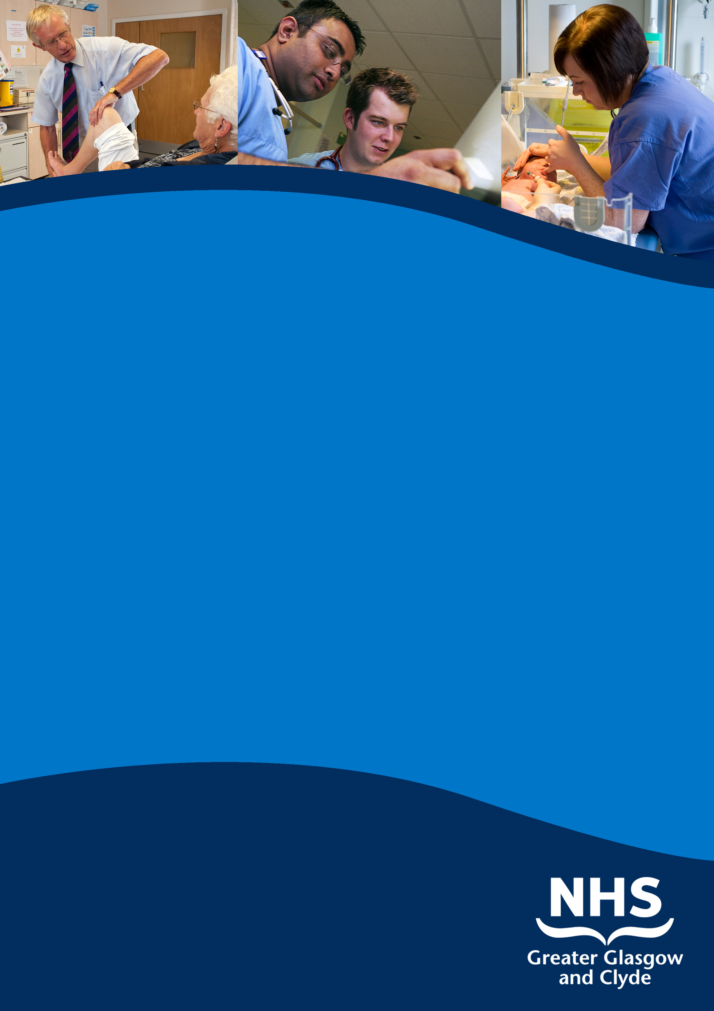

consultant otolaryngology
with a specialist interest in rhinology/anterior skull base surgery

NEW VICTORIA HOSPITAL/
queen elizabeth universitY hospital

INFORMATION PACK

REF: 42113D

cLOSING DATE: nOON 29th APRIL 2016

www.nhsggc.org.uk/medicaljobs

SUMMARY INFORMATION RELATING TO THIS POSITION

Post: CONSULTANT OTOLARYNGOLOGY WITH A SPECIALIST INTEREST IN RHINOLOGY/ANtERIOR SKULL BASE SURGERY

base: NEW VICTORIA HOSPITAL/QUEEN ELIZABETH UNIVERISTY HOSPITAL

Applications are welcomed from suitably qualified candidates for the above post, based at the New Victoria Hospital and the Queen Elizabeth University Hospital. This post is suitable for applicants with a subspecialty interest in Rhinology/ Anterior Skull Base Surgery.

The successful candidate will join a large team of ENT Consultants delivering elective, emergency and outpatient services across NHS Greater Glasgow and Clyde. They will be expected to work within the Multidisciplinary Skull Base team, and support development of the service. In May 2015, the Adult ENT inpatient and emergency service centralised in the state of the art facility in the new Queen Elizabeth University Hospital. Consultants participate in a 1 in 11 on call rota.

Applicants must have full registration with the General Medical Council and be eligible for inclusion in the GMC Specialist Register. Those trained in the UK should have evidence of higher Specialist Training leading to CCT or be within six months of confirmed entry from the date of interview. Non UK applicants must demonstrate equivalent training

For further information call Mr John Marshall, Clinical Director, on 0141 232 7545, or Mr David Crampsey, Lead Clinician, on 0141 211 1649.

NHS GREATER GLASGOW and CLYDE

CONSULTANT IN OTOLARYNGOLOGY
Rhinology/ Anterior Skull Base Surgery

REF: 42113D

Post of: Consultant in Otolaryngology and Head and Neck Surgery
Based at: New Victoria Hospital and Queen Elizabeth University Hospital

Brief Description of the Acute Services Division of NHS Greater Glasgow and Clyde

- Acute Services Division

NHS Greater Glasgow and Clyde is the Largest NHS Employer in the UK and in partnership with 8 local authorities, is responsible for the health needs of a population of 1.2 million, almost a quarter of the entire Scottish population. The Acute Services Division is split into nine Directorates across 18 sites with a workforce of 27,500 and an annual budget of £1.2 billion. The geographical area covered is diverse; it covers the major city of Glasgow, large and small towns, villages and some rural areas. We have significant challenges ahead as we deliver the objectives set out in Better Health Better Care and we seek to ensure that we have the right people for the right posts.

The Acute Services Division is the largest group of adult acute hospitals in Scotland. This allows individuals a wide range of opportunities for professional development whether in community-based care or general and specialty hospital services.

The investment in Acute hospital services in Glasgow in the last ten years has been considerable with two new Ambulatory Care Hospitals opened in 2009. Redevelopment of acute hospital estates has taken place to facilitate the centralisation of key specialties and integration of hospital sites in recent years. The Beatson West of Scotland Cancer Care Centre is a good example of the high standard of hospital development since transferring from the Western Infirmary to Gartnavel General in 2008.

- Queen Elizabeth University Hospital

The £850 million development created new adult and children’s hospitals. This brings Maternity, Children’s and Adult acute services together in one of the most advanced clinical provisions in Europe with the biggest Critical Care complex and Emergency Departments in Scotland. The Queen Elizabeth University Hospital was handed over at the end of January 2015 with clinical services migrating from the end of April.

This has resulted in the major reconfiguration of services across GG & C and consultants were actively involved in the planning of this exciting development. This is a time of transformational change across Glasgow and Clyde with the Queen Elizabeth University Hospital designated to become a trauma centre from 2016.

A new state of the art Teaching and Learning Facility has been built on the site. This is a joint venture between NHS Greater Glasgow and Clyde and the University of Glasgow. It is co-located with the Queen Elizabeth University Hospital providing benefits for staff and students and ultimately enhancing services for patients. The facility consolidates a series of fragmented training locations throughout Greater Glasgow and Clyde. The new building also houses the Stratified Medicine Scotland Innovation Centre which provides unique services to enable world leading developments in Stratified Medicine in chronic diseases.

A substantial volume of complex surgical work is performed in the Glasgow hospital units that provide a range of tertiary and national services. We enjoy close links with Glasgow’s 3 universities and make a significant contribution to teaching at both undergraduate and postgraduate level. Research also has a high profile within the organisation. We provide excellent facilities for students and their tutors in the £15 million, state of the art, Wolfson Medical School based at Glasgow University adjacent to the old Western Infirmary site.

- Living & Working in Glasgow

Today Glasgow is a compact, vibrant and modern city. The scale of the City comes as a surprise to many people. It has the largest suburban rail network outside London and is second only to the UK capital as a retail centre.

There are top-ranking schools, excellent leisure facilities, beautiful golf courses and elegant accommodation across all price ranges.

The night life and restaurants are renowned and its high quality opera, theatres, art galleries and museums offer an abundance of cultural stimulation.

From Glasgow, it is only a short journey to many picturesque sites including Loch Lomond (45 minutes), the Argyll peninsula – or over the sea to Arran, Skye, Iona and Mull.

- Description of the department

2015 saw the opening of the state of the art Queen Elizabeth University Hospital which provides a 29 bed centralized site for ENT major elective and all emergency inpatients. Outpatient services are also provided on this site along with Glasgow Royal Infirmary, New Stobhill Hospital, New Victoria Hospital, Vale of Leven Hospital, Gartnavel General Hospital, Royal Alexandra Hospital and Inverclyde Royal Hospital. Day surgery is undertaken at Gartnavel General, New Victoria Hospital, Royal Alexandra Hospital and Inverclyde Royal Hospital. The ENT inpatient service at the Queen Elizabeth University Hospital is co-located with Neurosurgery and Oral Maxillofacial surgery. The Department is supported by an audiology service, nurse practitioners and clinical nurse specialists. There is a recently re-established monthly meeting programme with departmental clinical governance and morbidity/mortality meetings, trainee and Consultant meetings. A research subgroup is taking forward the supervision of a visible and active trainee research/audit programme.
There are currently twenty-four Consultants employed within the Department of ENT in NHSGG&C.

The Consultants in post:
Consultant | Principal Sites |  | Interest
This post | Queen Elizabeth University Hospital /  New Victoria Hospital |  | Rhinology/ Anterior Skull Base Surgery
Mr B Bingham | New Victoria Hospital  Part time post retiral |  | Rhinology
Mr M Buchanan | Glasgow Royal Infirmary/ Gartnavel General Hospital |  | Head and Neck
Miss L Clark | Queen Elizabeth University Hospital /  New Victoria Hospital |  | Head and Neck Surgery/ Thyroid/ Parathyroid
Mrs L Cooke | Gartnavel General Hospital /  Vale of Leven Hospital |  | Otology
Mr D Crampsey | Gartnavel General Hospital /  Glasgow Royal Infirmary |  | Rhinology/ Vertigo  Lead Clinician
Mr J Crowther | Queen Elizabeth University Hospital /  New Victoria Hospital |  | Otology, Anterior and Lateral Skull Base.
Mr O Hilmi | Gartnavel General Hospital /  Glasgow Royal Infirmary |  | Benign Head and Neck / Rhinology
Miss A Hitchings | Queen Elizabeth University Hospital /  New Victoria Hospital |  | Head and Neck Surgery
Mr D Houghton | Queen Elizabeth University Hospital /  New Victoria Hospital |  | Head and Neck Surgery
Mr G Kontorinis | Queen Elizabeth University Hospital /  Vale of Leven Hospital/  New Victoria Hospital |  | Otology and Neurotology
Mr J Marshall | Queen Elizabeth University Hospital /  New Victoria Hospital |  | Otology/ Rhinology  Clinical Director
Miss J Montgomery | Royal Alexandra Hospital/ South Glasgow University Hospital |  | Head and Neck Surgery
Mr C Murray | Royal Alexandra Hospital | Otology / Paediatrics
Mrs C MacAndie | Royal Alexandra Hospital /  Inverclyde Royal Hospital | Otology
Prof G McGarry | Gartnavel General Hospital /  Glasgow Royal Infirmary | Head and Neck Surgery / Rhinology/ Anterior Skull Base
Miss F McGregor | Gartnavel General Hospital /  Queen Elizabeth University Hospital | Head and Neck Surgery

Prof K MacKenzie | Glasgow Royal Infirmary  (Part time post retiral) | Head and Neck Research
Mr A Robertson | Queen Elizabeth University Hospital /  Royal Alexandra Hospital/  Inverclyde Royal Hospital | Rhinology
Mr S Robertson | Queen Elizabeth University Hospital /  New Stobhill Hospital/  Glasgow Royal Infirmary | Head and Neck Surgery
Mr S Sheikh | Queen Elizabeth University Hospital /  New Victoria Hospital | Rhinology
Mr D Simpson | Stobhill Hospital | Rhinology/ Otology
Mr M Stewart | Queen Elizabeth University Hospital /  Inverclyde Royal Hospital | Head and Neck Surgery
Mr I Swan | Glasgow Royal Infirmary /  Gartnavel General Hospital | Otology
Mr A Tsikoudas | Gartnavel General Hospital | Rhinology
Advertisement | Queen Elizabeth University Hospital | Neuro-otology/ Lateral Skull Base

4. General description of the post

This post is a replacement post, and is suitable for qualified applicants with a subspecialty interest in Rhinology and Anterior Skull Base surgery +/- Pituitary Surgery. An appropriate Fellowship is desirable. The successful applicant will be working mainly at New Victoria Hospital and the new Queen Elizabeth University Hospital.

The appointee will be expected to join the existing Skull Base MDT and provide endoscopic anterior skull base surgery in association with Professor McGarry. While a defined interest and experience in this field of surgery is desirable, suitably qualified applicants can expect further training and mentoring from the existing Skull Base team members. The candidate should exhibit good team working skills as the Skull Base team consists of ENT, Neurosurgery and OMFS surgeons and Oncologists. Experience of, and desire to develop, an endoscopic pituitary service will also be looked on favourably.
The successful candidate would take part in the Pan Glasgow Consultant on-call rota supporting adult ENT out of hours. The on call frequency is 1 in 11.

5. Teaching
The successful candidate will participate in undergraduate and postgraduate
teaching. Regular participation in the departmental audit and clinical governance
sessions will be expected.

- Contract

This job plan is negotiable and will be agreed between the successful applicant and the Clinical Director. NHS Greater Glasgow & Clyde initially allocates all full time consultants 10 PAs made up of 9 PAs in Direct Clinical Care (DCC) and one core Supporting Professional Activities (SPA) for CPD, audit, clinical governance, appraisal, revalidation, job planning, internal routine communication and management meetings. The precise allocation of SPA time and associate objectives will be agreed with the successful applicant and will be reviewed at annual job planning.

The following PA allocation table is reflective of the working pattern:

Theatre | 2.25
Clinic | 4
On-call commitment | 0.5
Flexible DCC Theatre/Clinic | 1
Ant Skull Base MDT | 0.5
Other DCC includes admin | 0.75
Supporting PA’s | 1
Total PA’s | 10

The indicative timetable for this post is outlined below. This will be subject to negotiation by the successful applicant and the service.

 |  | Monday | Tuesday | Wednesday | Thursday | Friday
Week one | AM | New Vic OPD | Neuro theatre  Flex | New Vic OPD | SPA | Theatre Vic
 | PM | New Vic OPD |  | New Vic OPD | Skull Base MDT activity | Theatre Vic
Week two | AM | New Vic OPD | New Vic OPD Flex | New Vic OPD | SPA | Theatre Vic
 | PM | New Vic OPD | New Vic OPD Flex | New Vic OPD | Skull base MDT | Theatre Vic

8. Further information about the post / informal visit can be discussed with:-
Mr John Marshall, Clinical Director on 0141 232 7545
Professor Gerald McGarry, Consultant Rhinologist/ Anterior Skull Base Surgeon on 0141 211 4423

PERSON SPECIFICATION – CONSULTANT IN OTOLARYNGOLOGY (RHINOLOGY and ANTERIOR SKULL BASE SURGERY)
Qualifications and  Training | MBCHB or equivalent  FRCS or equivalent  Should have completed a recognised higher specialised training programme (or equivalent) in surgery with Higher Specialist Training in Otolaryngology/Head and Neck Surgery, with a subspecialty interest in rhinology i.e. must have a CCT or be within 6 months of attaining it. | Relevant higher degree
Clinical Experience | Wide experience in a surgical unit  Specific specialist interest experience in rhinology/ anterior skull base surgery  Ability to offer expert clinical opinion on all aspects of otolaryngology | A specialist interest within surgery complementary to the interests of existing consultants  Experience of shared care clinics and managed clinical networks
Audit/Research | Competence in clinical audit  Training in management and audit at StR or equivalent level | Able to initiate and carry out medical research projects.  Authorship of research papers, Publications in peer reviewed journals.  Ability to increase the academic profile of department  Experience in applications to ethical committees and grant applications
Teaching | Experience in training undergraduate medical students and postgraduate doctors  Interest in teaching | Specific training in education and/or appraisal  Qualification in Teaching
Management | Leadership skills  Knowledge of clinical governance  Evidence of experience and effectiveness in management | Experience of management  Specific management training
Other qualities | Demonstrable evidence of leadership skills  Evidence of effective team working  Evidence of good communication skills with patients, colleagues, and all team members  Evidence of flexibility, diplomacy and integrity. Willingness to undertake additional professional responsibilities at local, regional or national forum  Commitment to continuing professional development  IT Skills
Other Requirements | GMC Registration and a licence to practise.  Ability to meet on call requirements & Regional commitments

TERMS AND CONDITIONS OF SERVICE

The conditions of service are those laid down and amended from time to time by the Hospital and Medical & Dental Whitley Council.

TYPE OF CONTRACT | Permanent
GRADE AND SALARY | Consultant  £ 77,529 - £ 104,525 per annum (pro rata)  New Entrants to the NHS will normally commence on the minimum point of the salary scale, (dependent on qualifications and experience). Salary is paid monthly by Bank Credit Transfer.
HOURS OF DUTY | Full Time 40.00
SUPERANNUATION | New entrants to NHS Greater Glasgow and Clyde who are aged sixteen but under seventy five will be enrolled automatically into membership of the NHS Pension Scheme. Should you choose to "opt out" arrangements can be made to do this via: www.sppa.gov.uk
REMOVAL EXPENSES | Assistance with removal and associated expenses may be given and would be discussed and agreed prior to appointment.
EXPENSES OF CANDIDATES FOR APPOINTMENT | Candidates who are requested to attend an interview will be given assistance with appropriate travelling expenses. Re-imbursement shall not normally be made to employees who withdraw their application or refuse an offer of appointment.
TOBACCO POLICY | NHS Greater Glasgow and Clyde operate a No Smoking Policy in all premises and grounds.
DISCLOSURE SCOTLAND | This post is considered to be in the category of “Regulated Work” and therefore requires a Disclosure Scotland Protection of Vulnerable Groups Scheme (PVG) Membership.
CONFIRMATION OF ELIGIBILITY TO WORK IN THE UK | NHS Greater Glasgow and Clyde (NHSGGC) has a legal obligation to ensure that it’s employees, both EEA and non EEA nationals, are legally entitled to work in the United Kingdom. Before any person can commence employment within NHS GGC they will need to provide documentation to prove that they are eligible to work in the UK. Non EEA nationals will be required to show evidence that either Entry Clearance or Leave to Remain in the UK has been granted for the work which they are applying to do. Where an individual is subject to immigration control under no circumstances will they be allowed to commence until the right to work in the UK has been verified. ALL applicants regardless of nationality must complete and return the Confirmation of Eligibility to Work in the UK Statement with their completed application form. You will be required provide appropriate documentation prior to any appointment being made.
REHABILITATION OF OFFENDERS ACT 1974 | The rehabilitation of Offenders act 1974 allows people who have been convicted of certain criminal offences to regard their convictions as “spent” after the lapse of a period of years. However, due to the nature of work for which you are applying this post is exempt from the provisions of Section 4 of the Rehabilitation of Offenders Act 1974 by virtue of the Rehabilitation of Offenders Act 1974 (Exceptions Orders 1975 and 1986). Therefore, applicants are required to disclose information about convictions which for other purposes are “spent” under the provision of the act in the event of employment, failure to disclose such convictions could result in dismissal or disciplinary action by NHS Greater Glasgow and Clyde. Any information given will be completely confidential.
DISABLED APPLICANTS | A disability or health problems does not preclude full consideration for the job and applications from people with disabilities are welcome. All information will be treated as confidential. NHS Greater Glasgow and Clyde guarantees to interview all applicants with disabilities who meet the minimum criteria for the post. You will note on our application form that we ask for relevant information with regard to your disability. This is simply to ensure that we can assist you, if you are called for interview, to have every opportunity to present your application in full. We may call you to discuss your needs in more detail if you are selected for interview.
GENERAL | NHS Greater Glasgow and Clyde operates flexible staffing arrangements whereby all appointments are to a grade within a department. The duties of an officer may be varied from an initial set of duties to any other set, which are commensurate with the grade of the officer. The enhanced experience resulting from this is considered to be in the best interest of both NHS Greater Glasgow and Clyde and the individual.
EQUAL OPPORTUNITIES | The postholder will undertake their duties in strict accordance with NHS Greater Glasgow and Clyde’s Equal Opportunities Policy.
NOTICE | The employment is subject to three months’ notice on either side, subject to appeal against dismissal.
MEDICAL NEGLIGENCE | In terms of NHS Circular 1989 (PCS) 32 dealing with Medical Negligence the Health Board does not require you to subscribe to a Medical Defence Organisation. Health Board indemnity will cover only Health Board responsibilities. It may, however, be in your interest to subscribe to a defence organisation in order to ensure you are covered for any work, which does not fall within the scope of the indemnity scheme.

FURTHER INFORMATION

For further information on NHS Greater Glasgow and Clyde, please visit our website on www.nhsggc.org.uk

View all our vacancies at: www.nhsggc.org.uk/medicaljobs

Register for Job Alerts at: www.medicaljobs.scot.nhs.uk

Applicants wishing further information about the post are invited to contact David Crampsey on 0141 211 1649 or Mr John Marshall on 0141 232 7545 or Professor with whom visiting arrangements can also be made.

How to apply

To apply for these posts please include your CV and names and addresses of 3 Referees, along with the following documents; (click on the hyperlinks to open)

Medical and Dental Application and Equal Opportunities Monitoring Form

Declaration Form Regarding Fitness to Practice

Immigration Questionnaire

Alternatively please visit www.nhsggc.org.uk/medicaljobs and click on the “How to Apply” tab to access application for and CV submission information.

NOMINATION OF REFEREES

It is Board policy that no person can act as a member of an Advisory Appointments Committee and be a referee for a candidate for that post. You should therefore check with your proposed referees whether there is likely to be any difficulty in this respect for we may otherwise have to invite you to submit another name or names

Return of Applications

Please return your application by email to nhsggcrecruitment@nhs.net or to the recruitment address below;

Medical and Dental Recruitment Team
NHS Greater Glasgow and Clyde
Recruitment Services, 1st Floor
Modular Building, Gartnavel Royal Hospital
1055 Great Western Road
GLASGOW
G12 0XH

CLOSING DATE

The closing Date will be noon on 29th April 2016

INTERVIEW DATE

The interview date will be 22nd June 2016

