

consultant in palliative medicine

ardgowan hospice

INFORMATION PACK

REF: 43313D

cLOSING DATE: 29th JULY 2016

www.nhsggc.org.uk/medicaljobs

SUMMARY INFORMATION RELATING TO THIS POSITION

Post: CONSULTANT in palliative medicine

Base: ardgowan hospice

(Part time PA’s)

Ardgowan Hospice is seeking a dynamic and flexible individual to join our team at a very exciting phase in our development. You will support the shape of our new strategy “Ardgowan 2020” which has the people of Inverclyde at its heart.

Ardgowan Hospice is based in Greenock It is one of a number of specialist palliative care providers in the NHS Greater Glasgow and Clyde Health Board area. NHS GG&C support this post through formal contractual, supervisory and medical revalidation arrangements. Managerial and reporting arrangements are within the hospice.

The hospice has a tradition of dynamic and innovative practice and currently offers a full range of specialist palliative care services. The post also covers Hospital and community.

You will join a friendly, committed team, including another part time consultant and three experienced part time specialty doctors. You will collaborate closely with other providers in the region, including participation in a pan-Clyde second on call rota.

Greenock is in commuting distance of Glasgow with which it also has excellent rail links.

Applicants must have full GMC Registration, a licence to practise and be eligible for inclusion in the GMC Specialist Register. Those trained in the UK should have evidence of higher specialist training leading to CCT in Palliative Medicine or eligibility for specialist registration (CESR) or be within 6 months of confirmed entry from the date of interview. Non-UK applicants must demonstrate equivalent training.
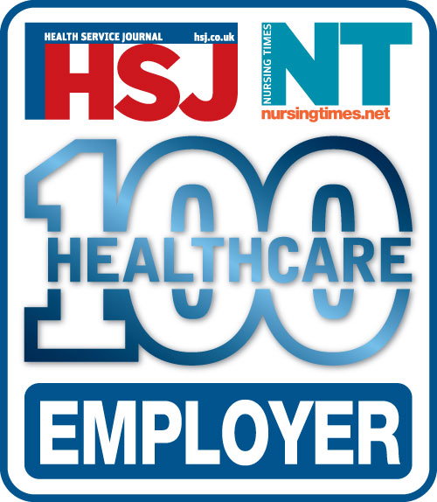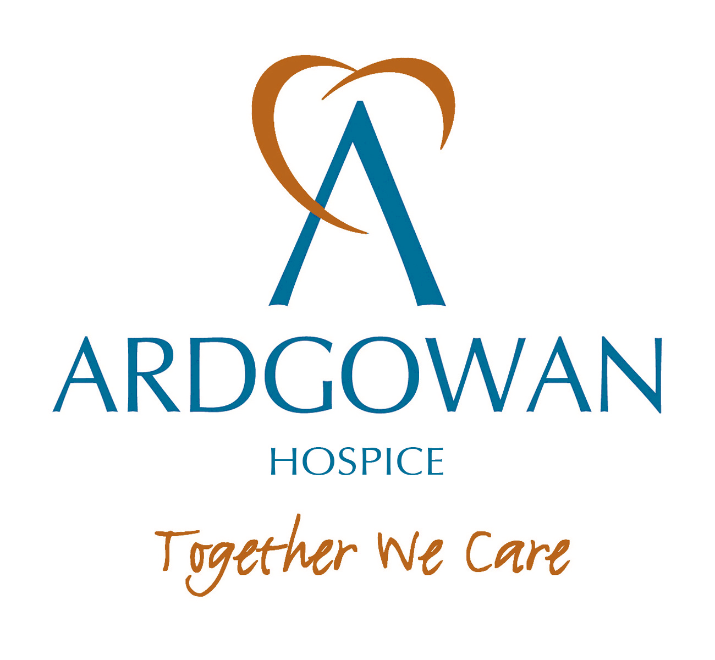

Ardgowan Hospice

Consultant in Palliative Medicine

Job Title: Consultant in Palliative Medicine for Ardgowan Hospice, Greenock
Employer: Ardgowan Hospice
Location: Ardgowan Hospice, Greenock and other locations in NHS Greater Glasgow and Clyde in order to fulfill the duties and responsibilities of the post.
Hours per week: Part time, based on 6 programmed activities (PA)
Accountability:
- Managerial - Chief Executive Ardgowan Hospice
- Managerial - Professional Medical Director RAD Directorate GG&C
- Specialty Professional - Clinical Lead for Palliative Care Greater Glasgow and Clyde Health Board.

Job Summary
The post holder will work as a member of the multi professional palliative care team, and along with the other part-time consultant provide leadership and take clinical responsibility for palliative care patients within the Hospice In-Patient Unit, Day Services, Lymphoedema and Out- Patient service. The post holder will provide specialist advice and contribute professional skills and knowledge to primary care and hospital services in Inverclyde engaging with clinicians across professional boundaries, networks and disciplines as required.
The holder of the post will have a lead role in maintaining and developing quality standards and clinical governance in Palliative Medicine.
A further requirement is for the post holder to contribute to the supervision, support and mentorship of the medical staff within the Hospice.
The model Job Plan attached is a draft to be finalised between the appointee and Chief Executive.

Professional Qualifications
The post holder should be registered with the General Medical Council and have a suitable higher qualification such as MRCP (UK) or (I), or MRCGP (UK) or (I) or equivalent. Candidates should also be on the specialist register for Palliative Medicine or be within 3 months of gaining the CCST.

Duties and Responsibilities of the Post
The following information outlines the main requirements of this post. The undernoted duties are not exhaustive and Ardgowan Hospice Board of Trustees reserves the right, following due consultation, to require the post holder to carry out additional duties as and when they become necessary, providing they are consistent with the main requirements of the post and that they fall within the post holders' capabilities and skills.

Clinical
- To provide clinical care and supervision as part of the multi professional team, for patients requiring specialist palliative care. This includes holistic care and symptom management for patients within the In- Patient, Day Services, Out- Patient and Lymphoedema services.
- To provide specialist medical advice and support for the team of Ardgowan Community Nurse Specialists. To visit patients at home as requested by the team of Nurse Specialists.
- To provide specialist palliative medical advice for Out-Patients as appropriate, liaising with GPs as required.
- To provide clinical supervision for Hospice medical staff.
- To participate in the Pan-Clyde consultant rota (second on call) for out of hours medical provision.
- To establish and develop effective working relationships with local GPs and other specialties in Inverclyde and the West of Scotland, e.g. Cancer Specialists, Radiologists, Cardiologists, Anaesthetists.
- To provide medical input to the strategic development of palliative care services within the NHS Greater Glasgow and Clyde Health Board area as appropriate.
- To be an effective source of expert clinical advice to external health professionals concerned with the care and treatment of people with palliative care needs, respecting their skills and autonomy.
- To liaise effectively with palliative care consultants within NHS Greater Glasgow and Clyde Health Board.

Education
- Participate in the multi-professional education programme and training for Hospice staff.

- To provide advice for education and training for multi-professional Hospital staff.

- To assist in developing the innovative programme of training in the field of palliative care, in conjunction with Ardgowan Hospice's Education Facilitator

- The teaching of students with the University of Glasgow Medical School and the University of the West of Scotland is expected in this role.

Management
- To provide effective medical management of the medical service.
- To report on medical matters to the Chief Executive, and to others as required.
- To have the ability to motivate, inspire and support multi-professional teams and be able to work effectively within such teams.
- To collaborate with colleagues on medical rotas to optimise medical cover in collaboration with the Chief Executive.

- To work efficiently and effectively within the resources approved by the Board of Trustees.

- To attend any meeting of appropriate groups, as convened by the Chief Executive or the management team.

- To provide mentorship of Hospice medical staff as required.

- To prioritise workload, delegating responsibilities as appropriate.
- To attend to administrative duties related to clinical care.

- To represent the Hospice and participate in appropriate external committees.
- To maintain effective internal and external working relationships, with particular reference to local GPs, community nurses, specialist palliative care Consultants and other specialists involved in patient care.

Clinical Governance
To have an active involvement in clinical effectiveness activities, risk management and to conduct regular audit of clinical care. Opportunities for research will be available with our partner institutions. There is a requirement for the postholder to participate in Consultant appraisal and revalidation processes (currently provided by Greater Glasgow & Clyde NHS Board) as per GMC.
Continued Professional Development
To maintain knowledge and skills in palliative medicine, ensuring that agreed study leave meets the minimum requirements for continuing professional development and revalidation.

Administrative Facilities and Support
The post holder will have appropriate office space, a personal computer and secretarial support.

Timetable
The working week consists of a total of 6 programmed activities to include 5 on direct clinical care and 1 sessions for supporting professional activities or additional responsibilities( the ratio of direct clinical to supporting professional activities and additional responsibilities is flexible depending on the needs of the service and subject to job planning).

On call
The appointee will provide 2nd on call in compliance with the European Working Times Directive. This is currently shared with the Consultants in Palliative Medicine from St Vincent’s Hospice, Howwood and Accord Hospice, Paisley.

General
The post-holder is expected to contribute to the smooth and efficient running of the service and to work with managers, professional colleagues and the Chief Executive to achieve this.
In relation to clinical work the post-holder is also expected to undertake all work in accordance with Ardgowan Hospice operating policies and procedures.

Health and Safety
Every staff member has a responsibility to ensure that the working environment is free from hazards to health and safety and to draw to the attention of the relevant Health and Safety Officer, any hazards they may have identified. All staff must take reasonable care of their own health and safety and that of others who may be affected by their work.

PERSON SPECIFICATION

Requirements | Essential | Desirable
Qualifications | - MRCP, MRCGP, FRCA,FRCR | - Diploma or Masters in palliative care
Training | - Applicants must have full GMC Registration, a licence to practise and be eligible for inclusion in the GMC Specialist Register. Those trained in the UK should have evidence of higher specialist training leading to CCT in Palliative Medicine or eligibility for specialist registration (CESR) or be within 6 months of confirmed entry from the date of interview. Non-UK applicants must demonstrate equivalent training.  - Membership of a recognised medical defence union
Experience | - Clinical experience in palliative medicine including hospice/hospital/home
Research, audit and teaching | - Critical thinker and able to put evidence into clinical practice.  - Committed to on -going CPD, appraisal and revalidation  - Commitment to teaching  - Participation in audit and quality improvement projects and evidence to show this  - Interest in Innovation and Improvement Science | - Publications in peer reviewed journals.  - Attendance at a teaching course  - Significant input to audit projects  - Evidence of research involvement
Knowledge | - Wide understanding of voluntary organisations and recent developments within the NHS  - Awareness of issues facing the NHS and independent hospices  - Good knowledge of clinical governance principles
Skills and abilities | - Integrity and demonstrated ability to promote the ethos of palliative care, as an individual and through team work  - Evidence of good personal organisation, including time management and meeting deadlines  - Evidence of effective interpersonal and communication skills, especially in handling difficult situations  - Evidence of ability to work within a multidisciplinary team, both as a member and as a leader  - Ability to relate to a wide range of people throughout the public, health and social care sectors  - Ability to offer high quality skills and experience in all aspects of palliative medicine
Management | - Willingness to further develop management skills  - Knowledge of what constitutes a good leader, good manager and good team player | - Have attended recognised managerial and or leadership course  - Service development experience
Physical | - Medically fit to fulfill the post and able to respond to emergencies as required
Other requirements | - Proof of appraisal status and revalidation (where appropriate by time) up to date.  - Respect, the mission and ethos of Ardgowan Hospice  - To develop good relationships with GPs and colleagues within Health and Social Care Partnerships  - Willingness to undertake supervision | - Enthusiasm to develop palliative care services within Ardgowan Hospice and in the Greater Glasgow and Clyde area  - Willingness and ability to travel to different locations

JOB PLAN (SUBJECT TO REVIEW AND NEGOTIATION)

This job plan is negotiable and will be agreed between the successful applicant and the Clinical Director. NHS Greater Glasgow & Clyde initially allocates all full time consultants 10 PAs made up of 9 PAs in Direct Clinical Care (DCC) and one core Supporting Professional Activities (SPA) for CPD, audit, clinical governance, appraisal, revalidation, job planning, internal routine communication and management meetings. The precise allocation of SPA time and associate objectives will be agreed with the successful applicant and will be reviewed at annual job planning.

DAY | TYPE OF WORK/LOCATION (SWAP EACH MONTH)
 | MONTH 1 | MONTH 2
Monday AM | Non Clinical | Ward Round
PM | Inverclyde Royal Hospital | OPC
Tuesday AM | OFF | OFF
PM | OFF | OFF
Wednesday AM | Clinical/OPC  MDT 09:30-10:30  (1st Wed of month) | MDT
PM | Community | Non Clinical
Thursday AM | Inverclyde Royal Hospital | Ward Round
PM | To be confirmed | To be confirmed
Friday AM | OFF | OFF
PM | OFF | OFF

TERMS AND CONDITIONS OF SERVICE

The conditions of service are those laid down and amended from time to time by the Hospital and Medical & Dental Whitley Council.

TYPE OF CONTRACT | Permanent
GRADE AND SALARY | Consultant  £ 77,529 to £ 104,525 per annum (pro rata)  New Entrants to the NHS will normally commence on the minimum point of the salary scale, (dependent on qualifications and experience). Salary is paid monthly by Bank Credit Transfer.
HOURS OF DUTY | Part Time 24.00
SUPERANNUATION | New entrants to NHS Greater Glasgow and Clyde who are aged sixteen but under seventy five will be enrolled automatically into membership of the NHS Pension Scheme. Should you choose to "opt out" arrangements can be made to do this via: www.sppa.gov.uk
REMOVAL EXPENSES | Assistance with removal and associated expenses may be given and would be discussed and agreed prior to appointment.
EXPENSES OF CANDIDATES FOR APPOINTMENT | Candidates who are requested to attend an interview will be given assistance with appropriate travelling expenses. Re-imbursement shall not normally be made to employees who withdraw their application or refuse an offer of appointment.
TOBACCO POLICY | NHS Greater Glasgow and Clyde operate a No Smoking Policy in all premises and grounds.
DISCLOSURE SCOTLAND | This post is considered to be in the category of “Regulated Work” and therefore requires a Disclosure Scotland Protection of Vulnerable Groups Scheme (PVG) Membership.
CONFIRMATION OF ELIGIBILITY TO WORK IN THE UK | NHS Greater Glasgow and Clyde (NHSGGC) has a legal obligation to ensure that it’s employees, both EEA and non EEA nationals, are legally entitled to work in the United Kingdom. Before any person can commence employment within NHS GGC they will need to provide documentation to prove that they are eligible to work in the UK. Non EEA nationals will be required to show evidence that either Entry Clearance or Leave to Remain in the UK has been granted for the work which they are applying to do. Where an individual is subject to immigration control under no circumstances will they be allowed to commence until the right to work in the UK has been verified. ALL applicants regardless of nationality must complete and return the Confirmation of Eligibility to Work in the UK Statement with their completed application form. You will be required provide appropriate documentation prior to any appointment being made.
REHABILITATION OF OFFENDERS ACT 1974 | The rehabilitation of Offenders act 1974 allows people who have been convicted of certain criminal offences to regard their convictions as “spent” after the lapse of a period of years. However, due to the nature of work for which you are applying this post is exempt from the provisions of Section 4 of the Rehabilitation of Offenders Act 1974 by virtue of the Rehabilitation of Offenders Act 1974 (Exceptions Orders 1975 and 1986). Therefore, applicants are required to disclose information about convictions which for other purposes are “spent” under the provision of the act in the event of employment, failure to disclose such convictions could result in dismissal or disciplinary action by NHS Greater Glasgow and Clyde. Any information given will be completely confidential.
DISABLED APPLICANTS | A disability or health problems does not preclude full consideration for the job and applications from people with disabilities are welcome. All information will be treated as confidential. NHS Greater Glasgow and Clyde guarantees to interview all applicants with disabilities who meet the minimum criteria for the post. You will note on our application form that we ask for relevant information with regard to your disability. This is simply to ensure that we can assist you, if you are called for interview, to have every opportunity to present your application in full. We may call you to discuss your needs in more detail if you are selected for interview.
GENERAL | NHS Greater Glasgow and Clyde operates flexible staffing arrangements whereby all appointments are to a grade within a department. The duties of an officer may be varied from an initial set of duties to any other set, which are commensurate with the grade of the officer. The enhanced experience resulting from this is considered to be in the best interest of both NHS Greater Glasgow and Clyde and the individual.
EQUAL OPPORTUNITIES | The postholder will undertake their duties in strict accordance with NHS Greater Glasgow and Clyde’s Equal Opportunities Policy.
NOTICE | The employment is subject to three months’ notice on either side, subject to appeal against dismissal.
MEDICAL NEGLIGENCE | In terms of NHS Circular 1989 (PCS) 32 dealing with Medical Negligence the Health Board does not require you to subscribe to a Medical Defence Organisation. Health Board indemnity will cover only Health Board responsibilities. It may, however, be in your interest to subscribe to a defence organisation in order to ensure you are covered for any work, which does not fall within the scope of the indemnity scheme.

FURTHER INFORMATION

For further information on NHS Greater Glasgow and Clyde, please visit our website on www.show.scot.nhs.uk

View all our vacancies at: www.nhsggc.org.uk/medicaljobs

Register for Job Alerts at: www.medicaljobs.scot.nhs.uk

Applicants wishing further information about the post are invited to contact Dr. Sandra McConnell on 01475 726830 or alternatively email on sandra.mcconnell@ardhosp.co.uk with whom visiting arrangements can also be made.

How to apply

To apply for these posts please include your CV and names and addresses of 3 Referees, along with the following documents; (click on the hyperlinks to open)

Medical and Dental Application and Equal Opportunities Monitoring Form

Declaration Form Regarding Fitness to Practice

Immigration Questionnaire

Alternatively please visit www.nhsggc.org.uk/medicaljobs and click on the “How to Apply” tab to access application for and CV submission information.

Return of Applications

Please return your application by email to nhsggcrecruitment@nhs.net or to the recruitment address below;

Medical and Dental Recruitment Team
NHS Greater Glasgow and Clyde
Recruitment Services, 1st Floor
Modular Building, Gartnavel Royal Hospital
1055 Great Western Road
GLASGOW
G12 0XH

CLOSING DATE

The closing Date will be 29th July 2016

INTERVIEW DATE

The interview date will be 2nd September 2016

