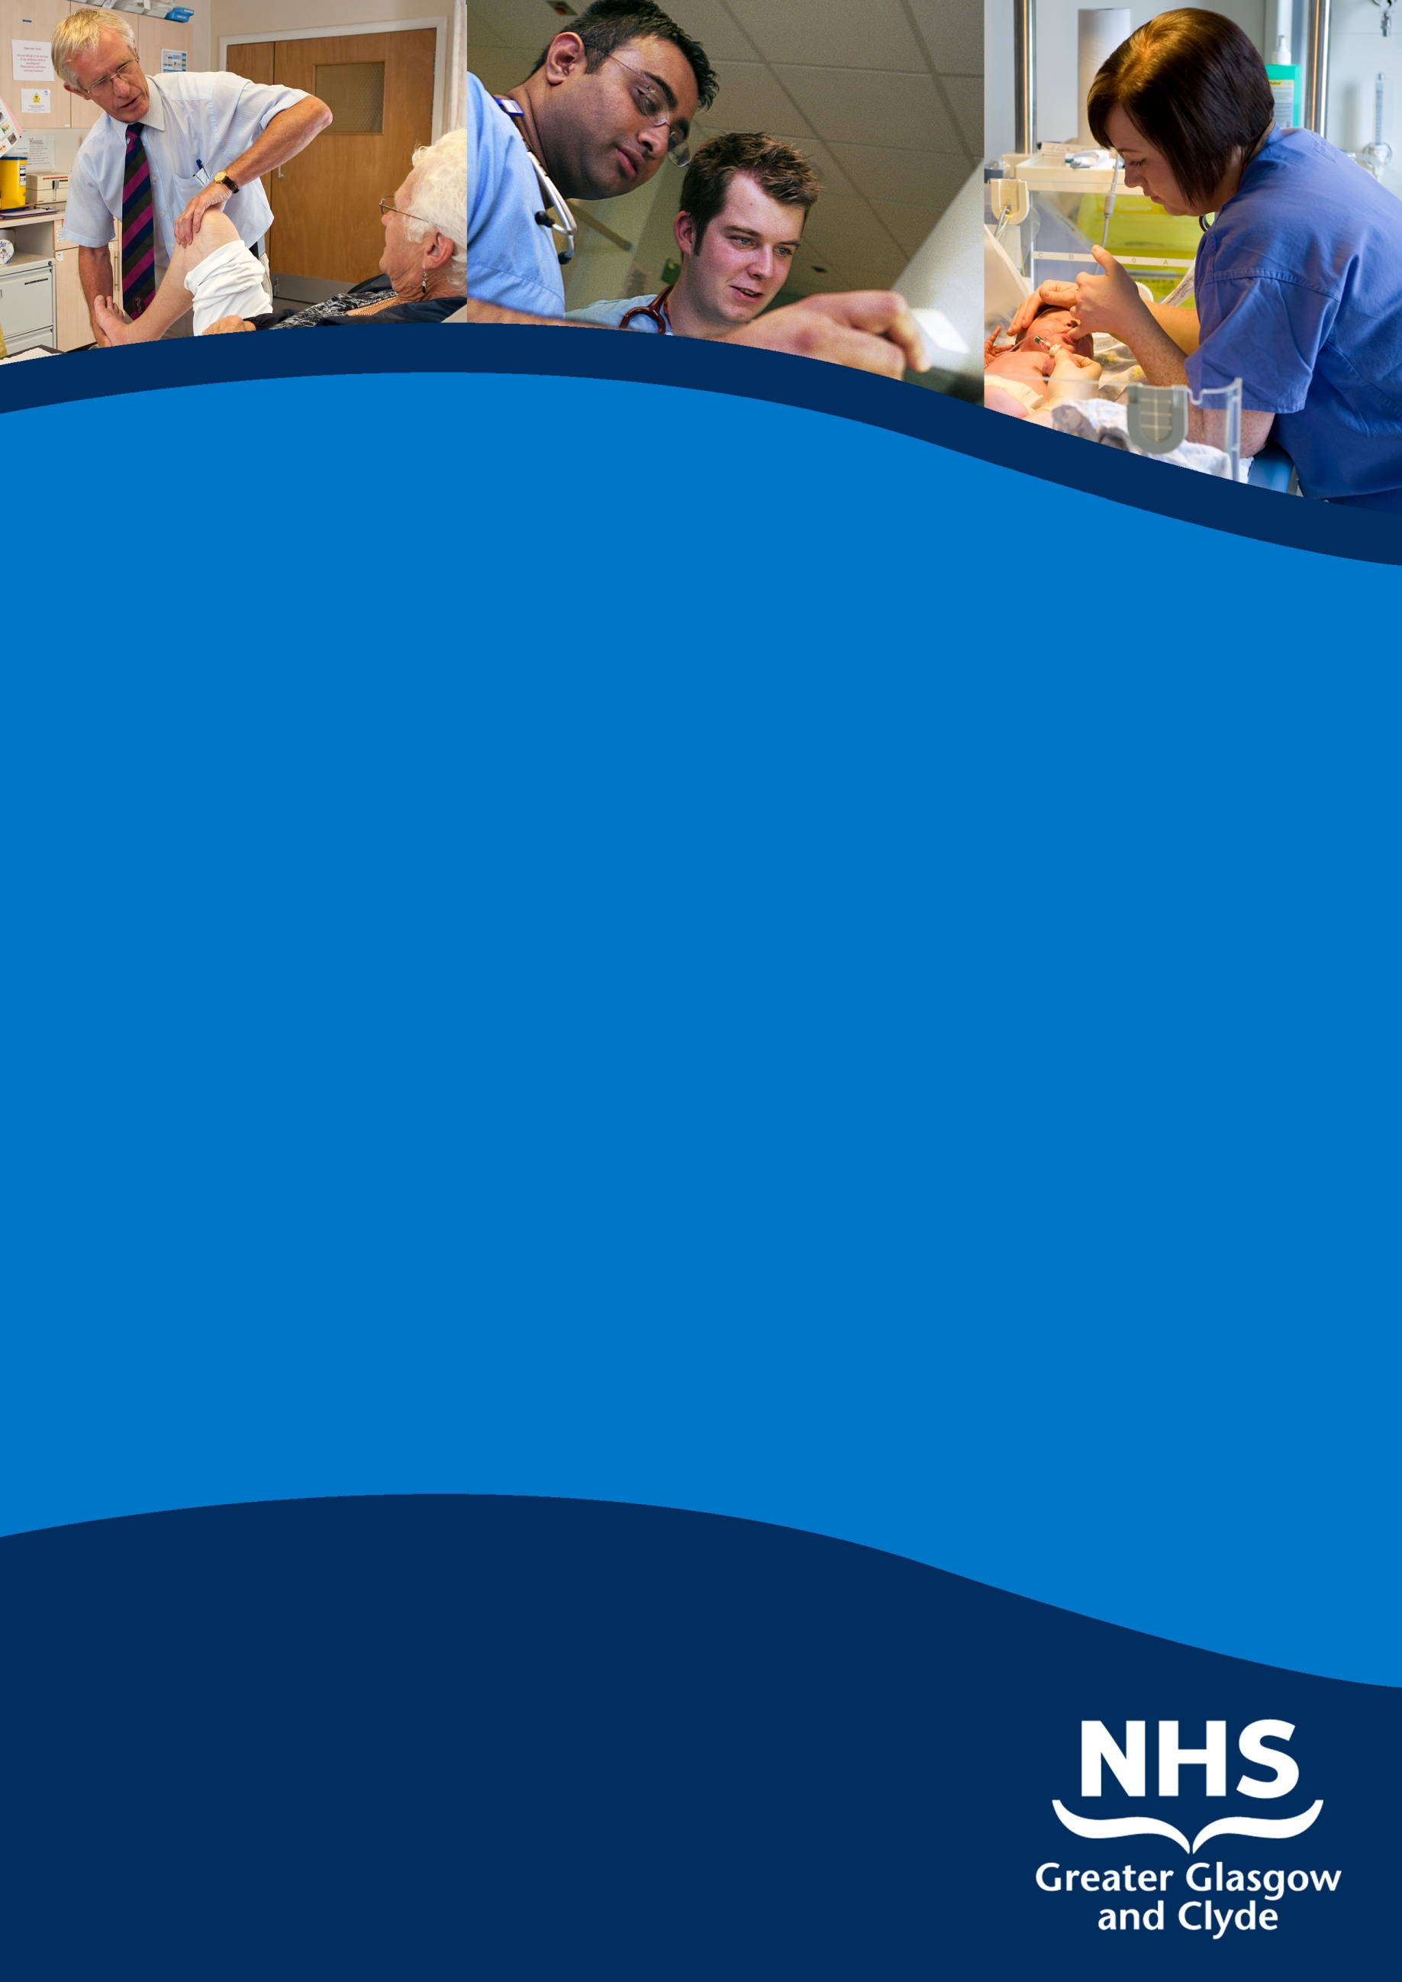

SENIOR clinical fellow in neurosurgery

Queen Elizabeth University Hospital Glasgow

Information pack

reF: 48812D

Closing Date: 22ND september 2017

www.nhsggc.org.uk/medicaljobs

SUMMARY INFORMATION

Post: sENIOR clinical fellow in neurosurgery

Base: Queen Elizabeth University Hospital, Institute of neurological Sciences

An opportunity has arisen for a Senior Clinical Fellow position within the Neurosurgical Department from as soon as possible until 31st July 2018. The appointment is based in the Department of Neurosurgery at Queen Elizabeth University Hospital, Institute of neurological Sciences, Glasgow. This is a large regional neurosurgical centre, which along with the neurosurgical department at the Royal Hospital for Children caters to the adult and paediatric population of the west of Scotland.

To practice medicine in the UK you need to hold both GMC registration and a license to practice.

This post does not have educational approval and will not be recognised for training.



ACUTE SERVICES DIVISION
REGIONAL SERVICES DIRECTORATE

INFORMATION PACK
FOR THE POST OF
SENIOR CLINICAL FELLOW IN NEUROSURGERY
BASED AT THE Queen Elizabeth University Hospital

CONTENTS

THE POST

- Job Description and Information about the Departments
- Information about the Division
- Terms and Conditions of Service
- Further information

1. GLASGOW – A GREAT PLACE TO LIVE AND WORK

Greater Glasgow and Clyde Valley is one of the world’s most thrilling and beautiful destinations. There is a wealth of attractions to discover, the UK’s finest Victorian architecture to astound, internationally acclaimed museums and galleries to inspire, as well as Glasgow’s own unique atmosphere to soak up.
Be entertained in one of Europe’s top cultural capitals by its year-long calendar of festivals and special events and enjoy outstanding shopping, superb bars and restaurants - all located within a stone’s throw of some of the country’s finest parks and gardens. The area also stands at the gateway to some of Scotland’s most spectacular scenery, with Loch Lomond and the Trossachs only 40 minutes away.
What’s more, we are easily accessible by air, rail and road so getting here could not be easier.

2. GREATER GLASGOW & CLYDE ACUTE SERVICES DIVISION

The Acute Division brings together all acute services across the city and Clyde under a single management structure led by the Chief Operating Officer. The Division is made up of 6 Directorates of clinical services each managed by a Director and clinical management team along with a Facilities Directorate. These are:
Emergency Care and Medical Services
Surgery and Anaesthetics
Rehabilitation and Assessment
Diagnostics
Regional Services
Women’s and Children’s Services
Facilities

This post is based within the Regional Services Directorate which includes:
Neuro-sciences (all sub-specialties except Neuro-radiology and neuropathology)
Specialist Oncology services (including Haemato-oncology)
Plastic Surgery and Burns
Renal Services including Renal Transplantation
Oral and Maxillofacial surgery
Homeopathy
Queen Elizabeth National Spinal Injuries Unit

3. THE QUEEN ELIZABETH UNIVERISTY HOSPITAL CAMPUS
The Queen Elizabeth University Hospitals Campus delivers a truly gold standard of healthcare on the Govan site with maternity, children’s and adult acute services all together on the one campus. It will also have the biggest Critical Care complex and one of the biggest Emergency Departments in Scotland. A new Laboratory and Facilities Management Building that is part of the project is now functional.
The Queen Elizabeth University Hospital
http://www.nhsggc.org.uk/content/mediaassets/images/sghc_concept_aerial_adult_hospital_ne_800.jpg
The plans for the complex will see a brand new 14-floor adult hospital with 1109 beds and state of the art Emergency, Acute Receiving, Critical Care, Theatres and Diagnostic Services that is set to open in early 2015. The facility will offer acute specialist inpatient care, medical day case services and also outpatient clinics servicing the local population.
The Royal Hospital for Children
http://www.nhsggc.org.uk/content/mediaassets/images/sghc_concept_childrens_hosp_park_800.jpg
A brand new children’s hospital, with a separate identity and entrance, will be adjoined to the adult hospital. With 256 beds over five storeys it will replace the existing Royal Hospital for Sick Children.
The Children’s Hospital will provide a large number of specialist services to the West of Scotland and the wider population of Scotland in addition to the full range of secondary care services to people of Greater Glasgow and Clyde. Specialist services include: cardiology and cardiac surgery, renal and bone marrow transplantation. For a number of these specialised services, the Children’s Hospital is recognised as the sole provider in Scotland. The new children’s hospital will not only be linked to the adult hospital but also to the redeveloped maternity hospital.
New Laboratory and Facilities Management Building
The laboratory will accommodate blood sciences, pathology, genetics, microbiology, postmortem and mortuary services. The laboratory will be linked to the new adult and children’s hospitals via an underground tunnel.
New Maternity Hospital
The refurbishment of the Southern General Maternity Unit was completed at the end of 2009, marking the latest milestone of our strategy to improve services for mothers and children across the city.
Among its world-class facilities is the brand new foetal medicine department providing specialist diagnostic facilities and treatment to unborn babies from across Scotland. The hospital is also a national centre for certain specialist services for newborn babies and provides state-of-the-art intensive care services. The Maternity building will be physically linked to the new children’s and adult hospitals via a walkway bridge.

4. THE QEUH / ROYAL HOSPITAL for SICK CHILDREN
The QEUH is a large teaching hospital with an acute operational bed complement of approximately 930 beds. The Hospital is sited in the south-west of Glasgow and provides a comprehensive range of acute and related clinical services. Glasgow’s Acute Services Review will see a new adult and paediatric hospital built on this site by 2015.
Services include Accident and Emergency, Dermatology, ENT, General Medicine (including sub-specialties), General Surgery (including sub-specialties), Medicine for the Elderly (including Assessment, Rehabilitation and Day Services), Gynaecology, Neonatal Paediatrics, Obstetrics, Ophthalmology, Orthopaedic Surgery, Urology, Physically Disabled Rehabilitation and Continuing Care. In-patient Maxillofacial (trauma and elective surgery and specialist provision for head and neck cancer), Dermatology and the Assessment and Rehabilitation service for the Physically Disabled are also provided for the whole city from the Southern General Hospital.
There is also a wide range of therapeutic services including Audiology, Clinical Psychology, Dietetics, Occupational Therapy, ECG, Physiotherapy, Radiology (including MRI and CT provision for the general hospital service) and Speech Therapy.
The Institute of Neurological Sciences
The Institute of Neurological Sciences is based on the QEUH campus and provides Neurosurgical, Neurological, Clinical Neurophysiology, Neuroradiological and Neuropathology facilities for the West of Scotland. The Institute is equipped with a Magnetic Resonance Imaging Suite, SPECT Scanner, two Computerised Axial Tomography Scanners, and angiography facilities. The Institute has ICU, HDU and outpatient facilities and also houses ENT and Oral & Maxillofacial Services.
Spinal Injuries Unit
The Queen Elizabeth National Spinal Injuries Unit for Scotland provides a spinal injuries service to the whole of Scotland. This is housed in a purpose-built facility.

University Links
The QEUH has built a sound academic and research base over the years, and has an excellent teaching reputation with libraries and lecture suites with comprehensive audio/visual facilities on site. There are close links with the University of Glasgow's Faculty of Medicine including Professors within Neurosciences.
The Royal Hospital for Sick Children
Children’s Services are managed within the Women & Children’s Directorate located within the Yorkhill Campus which hosts the Royal Hospital for Sick Children. Maternity services are currently provided at the Southern General Hospital and the Princess Royal Maternity Hospital both located within 5 miles of the Yorkhill Campus

The Royal Hospital for Sick Children (RHSC) is the largest paediatric teaching hospital in Scotland. It provides care not only for children resident within Greater Glasgow, but is also a tertiary referral centre for children from the West of Scotland.

Plans are currently being finalised for a new Children's Hospital to be built on the Southern General Hospitals campus by 2015. This new facility will allow co-adjacency with both maternity services and neurosciences.

5. NATIONAL MANAGED SERVICE NETWORK

The Department of Neurosurgery in Glasgow is one of four Scottish Neurosurgical centres, which are now part of a national managed service network (MSN). Formed in 2009, the MSN is an innovative model, the first of its kind in Scotland. Building on the fundamental principles of Managed Clinical Networks and extending these across the whole service, it aims to ensure that neurosurgical services in Scotland are equitable and consistent in terms of access and quality. The MSN is responsible for ensuring a national approach to the development of services, for the development, implementation and assessment of nationally agreed service standards and care pathways, and for the promotion of nationally coordinated research and development. Good quality, consistent data are fundamental to progress in these areas.

The MSN offers enormous opportunity for the pursuit of specialist interest(s) within the Scotland-wide context provided by the Network. In addition to taking a full share of the general neurosurgical workload in Glasgow and developing and strengthening services locally, the post holder will be encouraged to take an active role in working within the MSN to develop specialist services within a national perspective.

The MSN structure is headed by a Network Board and supported by an operational management group which is currently chaired by the national Clinical Director, Mr Eric Ballantyne, Consultant Neurosurgeon, Ninewells Hospital, Dundee.

6. WORK OF THE DEPARTMENT

The Department of Neurosurgery is situated within the main block of the Institute of Neurological Sciences (INS) at the Southern General Hospital. The Unit supplies a regional service to a population of 2.7 million, mainly from the West of Scotland (NHS Greater Glasgow and Clyde, NHS Ayrshire & Arran, NHS Lanarkshire, NHS Highland and NHS Western Isles), although some patients are referred from other areas of Scotland or England for sub-specialty care.

Neurosurgery is part of the Regional Services Directorate for NHS Greater Glasgow and Clyde. Each Department within Neurosciences, OMFS and Spinal Injuries has a management-appointed Lead Clinician.

The department has close links with the Departments of Neurology, Neuropathology, Neuro-anaesthesia, Neuroradiology, Maxillofacial Surgery and Clinical Physics, with Paediatric services at Yorkhill Hospital and with the Oncology Services at the Beatson Cancer Centre. The department also has visiting specialists from Neuro-ophthalmology and Neuro-otology.

The Neurosurgical Department works on a team system with three clinical teams. Consultants are involved in undergraduate and postgraduate teaching, and are when necessary offered an honorary position by the University of Glasgow. There is a long history of successful clinical research and all Consultants and junior staff are encouraged to participate. There are opportunities through the University Department of Clinical Neurosciences to carry out basic research.

There are 69 adult neurosurgical beds and a suite of three neurosurgical theatres located next to the two maxillofacial theatres. In addition, there is a six-bedded ITU and a four-bedded HDU shared with the other specialties within the Division. The Neurosurgical teams are based around the three adult wards. There are ten specialist trainees at ST3 or above, as well as ten further junior trainees at FY2/ ST1-2/ Junior Clinical Fellow grades who rotate between the teams. Routine emergency and elective work within the Unit is sub-divided approximately equally between teams but within this framework the development of special interests is established and encouraged.

The post offers excellent opportunities for modern neurosurgical practice. There is close collaboration with Interventional Radiologists, Maxillofacial Surgeons, and Neuro-otologists. The National Spinal Injuries Unit is located in an adjoining building to the Institute, and there is a close working relationship between the two Units.

Paediatric neurosurgery is carried out at the Royal Hospital for Sick Children (RHSC) at Yorkhill by a team of four consultant neurosurgeons. This is an interim arrangement until the RHSC closes and the New Children’s hospital opens on the Southern General Hospital site in 2015 (see section 3 above).

7. THE JOB

Title: SENIOR CLINICAL FELLOW

The post-holder will join the middle grade tier of doctors in the department. They will participate in a shift rota that is compliant with the EWTD.

Relationships

NHS Consultants: There are 16 WTE consultant neurosurgeons, 11 Higher Surgical Trainees and 10 junior doctors (FY2 / FTSTA / ST 1or2 / Junior Clinical Fellows) in the department. Staff are organised into 3 teams. Consultants have different subspecialty interests. Registrars move between the teams, ensuring exposure to a wide range of urgent and elective neurosurgical conditions, including paediatric and spinal neurosurgery.

Duties of the Post

The duties and responsibilities of the post are the same as those of the specialist/ specialty registrars.

(i) Ward work: The wards are staffed by 10 junior doctors (FY2, ST1) on a shift system; Registrars supervise the day-to-day care of neurosurgical inpatients under the overall supervision of the responsible Consultant.
- Night and weekend commitment: Registrars operate a rota of resident shift rota with prospective cover. During out of hours, the unit is staffed by a junior doctor providing ward cover, and the registrar, who is responsible for receiving emergency calls, and covering emergencies.
- Out-patient and theatre duties: Registrars will be expected to attend clinics and theatre sessions, under the supervision of the responsible consultant. The unit has a high theatre workload both elective and emergency, and the post holder can expect to gain a broad operative experience during the year in post.

- STUDY AND TRAINING

There is an in-house programme of weekly registrar teaching provided by the consultant and other staff to which the registrar is invited. Attendance at the weekly neuropathology and neuroradiology meetings is encouraged. Wednesday mornings are set aside for academic meetings including case presentations, clinico-pathological conferences and invited lectures, and involves the whole Institute. There is an ongoing programme of audit and clinical governance.

9. CONDITIONS OF SERVICE

The post is covered by the Terms and Conditions of Service for Hospital Medical and Dental Staff (Scotland), as amended from time to time by central negotiations and by General Whitley Council Conditions of Service where appropriate.

In addition, an out of hours supplement is payable. Please note that the Division regularly undertaking monitoring therefore the current banding may be subject to change. An offer of Employment may not reflect the current Banding.

It is a condition of the appointment that the holder of the post shall hold full registration with the General Medical Council and licence to practise.

New entrants to the Health Service may be required to undergo a medial examination prior to confirmation of the appointment.

11. INFORMAL ENQUIRIES

Informal enquiries shoud be directed to: Mr C Mathieson, Chairman, Dept Neurosurgery, via his secretary (phone 0141 201 2107). Applicants who are shortlisted for interviews will be given the opportunity to visit the unit.

TERMS AND CONDITIONS OF SERVICE

The conditions of service are those laid down and amended from time to time by the Hospital and Medical & Dental Whitley Council.

TYPE OF CONTRACT | Fixed Term
GRADE AND SALARY | Senior Clinical Fellow  £ 31,220 - £ 49,091 per annum (pro rata)  New Entrants to the NHS will normally commence on the minimum point of the salary scale, (dependent on qualifications and experience). Salary is paid monthly by Bank Credit Transfer.
HOURS OF DUTY | Full Time 40.00
SUPERANNUATION | New entrants to NHS Greater Glasgow and Clyde who are aged sixteen but under seventy five will be enrolled automatically into membership of the NHS Pension Scheme. Should you choose to "opt out" arrangements can be made to do this via: www.sppa.gov.uk
REMOVAL EXPENSES | Assistance with removal and associated expenses may be given and would be discussed and agreed prior to appointment.
EXPENSES OF CANDIDATES FOR APPOINTMENT | Candidates who are requested to attend an interview will be given assistance with appropriate travelling expenses. Re-imbursement shall not normally be made to employees who withdraw their application or refuse an offer of appointment.
TOBACCO POLICY | NHS Greater Glasgow and Clyde operate a No Smoking Policy in all premises and grounds.
DISCLOSURE SCOTLAND | This post is considered to be in the category of “Regulated Work” and therefore requires a Disclosure Scotland Protection of Vulnerable Groups Scheme (PVG) Membership.
CONFIRMATION OF ELIGIBILITY TO WORK IN THE UK | NHS Greater Glasgow and Clyde (NHSGGC) has a legal obligation to ensure that it’s employees, both EEA and non EEA nationals, are legally entitled to work in the United Kingdom. Before any person can commence employment within NHS GGC they will need to provide documentation to prove that they are eligible to work in the UK. Non EEA nationals will be required to show evidence that either Entry Clearance or Leave to Remain in the UK has been granted for the work which they are applying to do. Where an individual is subject to immigration control under no circumstances will they be allowed to commence until the right to work in the UK has been verified. ALL applicants regardless of nationality must complete and return the Confirmation of Eligibility to Work in the UK Statement with their completed application form. You will be required provide appropriate documentation prior to any appointment being made.
REHABILITATION OF OFFENDERS ACT 1974 | The rehabilitation of Offenders act 1974 allows people who have been convicted of certain criminal offences to regard their convictions as “spent” after the lapse of a period of years. However, due to the nature of work for which you are applying this post is exempt from the provisions of Section 4 of the Rehabilitation of Offenders Act 1974 by virtue of the Rehabilitation of Offenders Act 1974 (Exceptions Orders 1975 and 1986). Therefore, applicants are required to disclose information about convictions which for other purposes are “spent” under the provision of the act in the event of employment, failure to disclose such convictions could result in dismissal or disciplinary action by NHS Greater Glasgow and Clyde. Any information given will be completely confidential.
DISABLED APPLICANTS | A disability or health problems does not preclude full consideration for the job and applications from people with disabilities are welcome. All information will be treated as confidential. NHS Greater Glasgow and Clyde guarantees to interview all applicants with disabilities who meet the minimum criteria for the post. You will note on our application form that we ask for relevant information with regard to your disability. This is simply to ensure that we can assist you, if you are called for interview, to have every opportunity to present your application in full. We may call you to discuss your needs in more detail if you are selected for interview.
GENERAL | NHS Greater Glasgow and Clyde operates flexible staffing arrangements whereby all appointments are to a grade within a department. The duties of an officer may be varied from an initial set of duties to any other set, which are commensurate with the grade of the officer. The enhanced experience resulting from this is considered to be in the best interest of both NHS Greater Glasgow and Clyde and the individual.
EQUAL OPPORTUNITIES | The postholder will undertake their duties in strict accordance with NHS Greater Glasgow and Clyde’s Equal Opportunities Policy.
NOTICE | The employment is subject to one months’ notice on either side, subject to appeal against dismissal.
MEDICAL NEGLIGENCE | In terms of NHS Circular 1989 (PCS) 32 dealing with Medical Negligence the Health Board does not require you to subscribe to a Medical Defence Organisation. Health Board indemnity will cover only Health Board responsibilities. It may, however, be in your interest to subscribe to a defence organisation in order to ensure you are covered for any work, which does not fall within the scope of the indemnity scheme.

FURTHER INFORMATION

For further information on NHS Greater Glasgow and Clyde, please visit our website on www.nhsggc.org.uk

View all our vacancies at: www.nhsggc.org.uk/medicaljobs

Register for Job Alerts at: www.medicaljobs.scot.nhs.uk

Applicants wishing further information about the post are invited to contact Mr Suttner or Mr Mathieson on 0141 201 2108 with whom visiting arrangements can also be made.

How to apply

To apply for these posts please include your CV and names and addresses of 3 Referees, along with the following documents; (click on the hyperlinks to open)

Medical and Dental Application and Equal Opportunities Monitoring Form

Declaration Form Regarding Fitness to Practice

Immigration Questionnaire

Alternatively please visit www.nhsggc.org.uk/medicaljobs and click on the “How to Apply” tab to access application for and CV submission information.

NOMINATION OF REFEREES

It is Board policy that no person can act as a member of an Advisory Appointments Committee and be a referee for a candidate for that post. You should therefore check with your proposed referees whether there is likely to be any difficulty in this respect for we may otherwise have to invite you to submit another name or names

Return of Applications

Please return your application by email to nhsggcrecruitment@nhs.net or to the recruitment address below;

Medical and Dental Recruitment Team
NHS Greater Glasgow and Clyde
West Glasgow ACH (formerly Yorkhill)
2nd Floor
Dalnair Street,
Yorkhill,
G3 8SJ

CLOSING DATE

The closing Date will be

22nd September 2017

