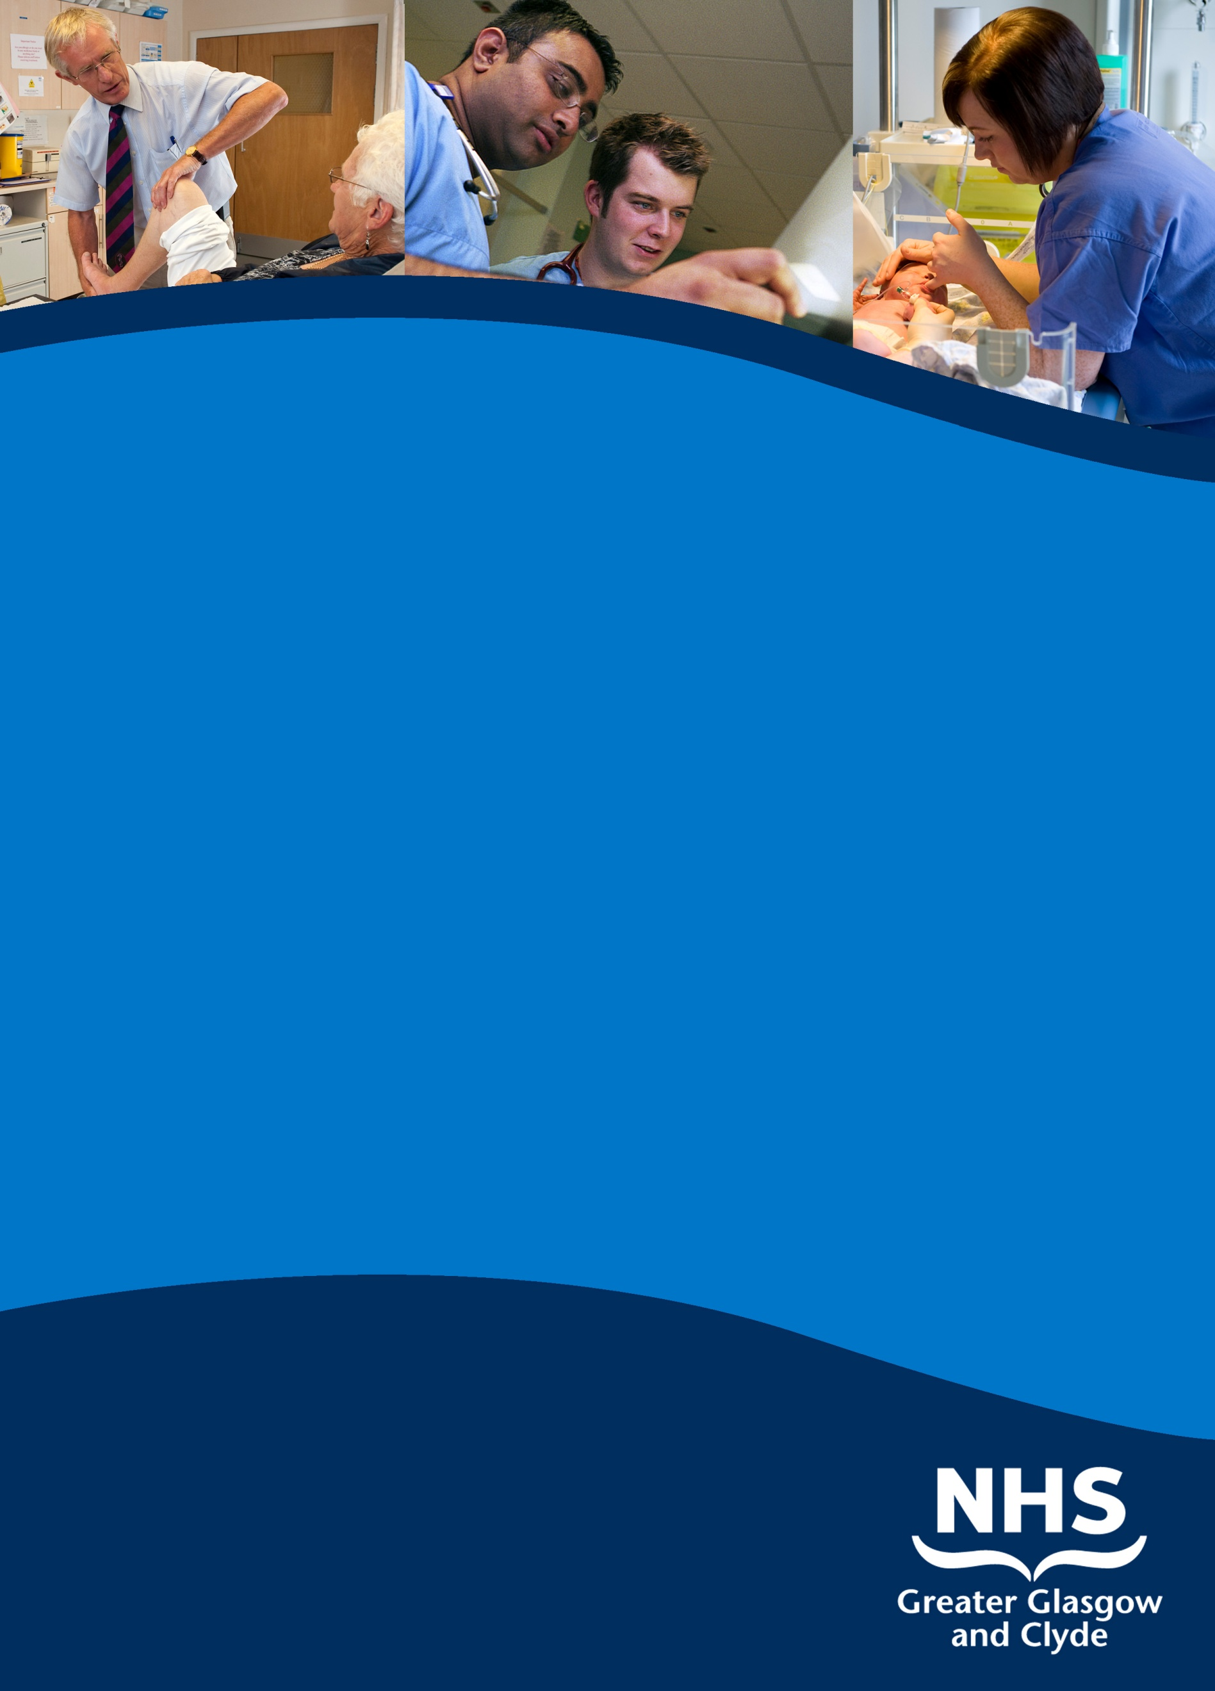

**LOCUM consultant in obstetrics & gynaecology**

**PRINCESS ROYAL MATERNITY / GLASGOW ROYAL INFIRMARY**

**Information pack**

**reF: 43419D**

**Closing Date: 22nd July 2016**

[www.nhsggc.org.uk/medicaljobs](http://www.nhsggc.org.uk/medicaljobs)

**SUMMARY INFORMATION**

**Post: locum consultant in obstetrics WITH on-call component**

**Base: princess royal maternity HOSPITAL/glasgow royal infirmary**

Applications are welcomed for full time (40 hours per week) locum position for 6 months based in theGlasgow Royal Infirmary.The successful applicants will join an established team of consultants providing a comprehensive service to the population of Glasgow.

The focus of this post will be Obstetrics, with sessions including antenatal clinics, Obstetric ultrasound and caesarean section lists. Obstetric on call will be provided by this post holder. Contribution to the Gynaecology service would be an option, depending on the skills of the candidates.

More detailed departmental and specialty information can be found in the job descriptions below.

Applicants must have full GMC registration and a licence to practise.

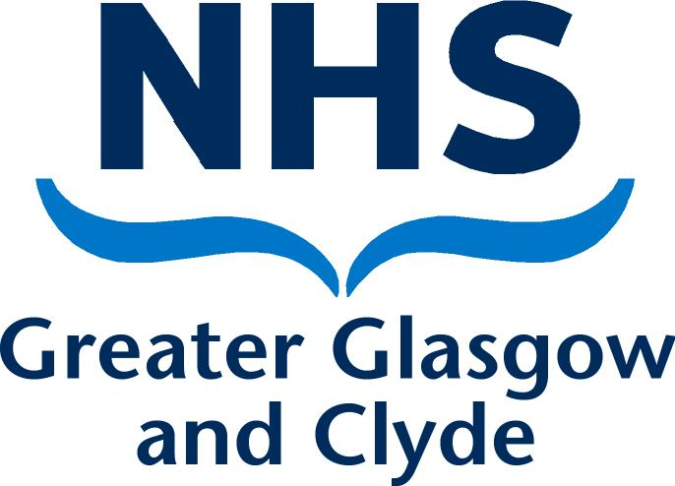

#### Posts

#### Acute Services Division

**Women & Children’s Directorate**

1. **GLASGOW – A GREAT PLACE TO LIVE AND WORK**

Greater Glasgow and Clyde Valley are one of the world’s most ­thrilling and beautiful destinations.

There is a wealth of attractions to discover, the UK’s finest Victorian ­architecture to astound, internationally acclaimed museums and galleries to inspire, as well as Glasgow’s own unique atmosphere to soak up.

Be entertained in one of Europe’s top cultural capitals by its year-long calendar of festivals and special events and enjoy outstanding shopping, superb bars and ­restaurants - all located within a stone’s throw of some of the country’s finest parks and gardens.

The area also stands at the gateway to some of Scotland’s most spectacular scenery, with Loch Lomond and the Trossachs only 40 minutes away.

What’s more, we are easily accessible by air; rail and road so getting here could not be easier.

**2. THE HOSPITAL MODERNISATION PROGRAMME - THE SERVICES OF TOMORROW**

Health services in Glasgow have completed a major Hospital Modernisation Programme. This ten-year £700 million strategy has seen the transformation of acute services across the city including the replacement of out-dated Victorian buildings and the creation of one-stop/rapid diagnosis and treatment models for the vast majority of patients. The last major piece of this plan completed with the opening of the new Queen Elizabeth University Hospital in May 2015.

Core adult acute care is now delivered from four sites within Glasgow. Gartnavel General Hospital delivers acute care in the west-end of the city. In the north-east of the city acute care is delivered from Stobhill Hospital and Glasgow Royal Infirmary. The Queen Elizabeth University Hospital provides acute adult care for the south of the city. In-patient services for the south have now been concentrated in the Queen Elizabeth University Hospital built on the site of the previous Southern General Hospital. This new facility, housing some 850 beds, has replaced ageing acute wards in both the Southern General Hospital and the Victoria Infirmary. The new hospital works alongside some of the relatively modern buildings housing specialist services, which will be retained on the Queen Elizabeth University Hospital site as part of the Strategy. The new hospital is home to one of two Accident and Emergency and Major Trauma Units covering the whole of the city.

The children’s hospital has relocated from Yorkhill to the new £100 million building on the Queen Elizabeth University Hospital site sitting alongside and is fully integrated with maternity and adult services.

Full adult Accident and Emergency services are only provided at Glasgow Royal Infirmary and the Queen Elizabeth University Hospital.

The Hospital Modernisation Programme ensures that walk-in/walk-out hospital services are provided for the majority of patients. The pattern of service provision reflects the move towards ambulatory care. Currently 85% to 90% of patient encounters with acute hospital services are on a walk-in/walk-out same day basis. These include out-patient attendances, diagnostic tests, imaging procedures, and a range of day surgery procedures. These services are now provided from award winning ambulatory care hospitals (ACH) designed to deliver the streamlined process of care, which patients want - to be seen quickly by the appropriate specialist, to undergo clinical investigation, and to receive treatment without delay.

Two ambulatory care centres for the city are in new purpose-built hospitals next to the current Victoria Infirmary and on the Stobhill Hospital site. These state-of-the-art facilities opened in 2009 and house the main out-patient centres and day surgery services for the city.

The redesign and redevelopment of Glasgow’s acute services has addressed many of the pressures currently facing the hospital service. The new services will be provided in modern facilities rather than in 19th century buildings not designed for modern healthcare. The purpose-designed facilities will enable the one-stop/rapid diagnosis and treatment models required for the future. Continuity of service will improve with the elimination of the need for patients’ notes and results to be moved from building to building. Concentration of services will allow the requirements of junior doctors hours and issues arising from increasing sub-specialisation of medicine to be addressed through the creation of larger staff teams and sustainable rotas for both junior and senior staff.

The formation of larger clinical teams will make sure that programmes of work, including the need to cover emergencies without interfering with waiting list and ambulatory care sessions, can be planned effectively. The concentration of in-patient services on fewer sites will help strengthen specialist services and maximise the capacity of the service.

**3. GREATER GLASGOW & CLYDE ACUTE SERVICES DIVISION**

**Glasgow Acute Services Clyde Acute Services**

15 Hospitals 3 Hospitals



4,700 beds 1,100 beds



£980m income £250m income



19,500 wte staff 7,000 wte staff



The Acute Division brings together all acute services across the city and Clyde under a single management structure led by the Chief Operating Officer. The Division is made up of three sectors {North, South and Clyde}. Each service is managed by a Director and clinical management team along with a Facilities Directorate.

Women and Children’s Services, Regional Services and Diagnostics are managed citywide whilst the other services are managed on a sector basis.

**Services across the sites include:**

|  |  |
| --- | --- |
| Accident and Emergency services  Acute Medicine  Cardiology/Coronary Care  Respiratory Medicine  Renal Medicine  Gastroenterology  Diabetes  Infectious Diseases  Rheumatology  Dermatology  out-of-hours GP service  Stroke  Frail elderly  Palliative Care  Inpatient Physically Disabled  West of Scotland Mobility and Rehabilitation Centre (Westmarc)  Physiotherapy  Dietetics  Speech and Language Therapy  Rehabilitation  Palliative care  Specialist community disability services  Pain services  Continence services to care homes  Falls prevention | General Surgery – including vascular and breast surgery  Orthopaedics / trauma  Anaesthetics – including critical care  Ophthalmology  Optometry  ENT Surgery  Audiology  Endoscopy  Urology  Neurosciences [including all sub-specialties except neuro-radiology]  Specialist Oncology services [including haemato-oncology]  Plastic Surgery and Burns  Cardiothoracic Surgery  Renal Transplantation  Oral and Maxillofacial surgery  Homeopathy  All Laboratory Medicine including Paediatrics  Diagnostic imaging [including Beatson radiological services]  Vascular and Interventional Radiology  Breast Screening services |

**Women’s and Children’s Services**

This Directorate brings together maternity, gynaecology and children’s services.

The Directorate includes:

Obstetrics



Gynaecology



Neonatology



Paediatric Medicine



Paediatric Surgery



Paediatric Accident and Emergency



Paediatric Anaesthetics



Paediatric Radiology



**4. OBSTETRICS and GYNAECOLOGY**

£60m + Budget



1,150 wte staff



**Obstetrics**

3 inpatient hospitals: Princess Royal Maternity, GRI; Queen Elizabeth University Hospital, Royal Alexandra Hospital, Paisley (with two linked community midwifery units at Inverclyde & Vale of Leven DGH: status under review)



**Gynaecology**

3 departments: Glasgow Royal Infirmary; Queen Elizabeth University Hospital Royal Alexandra Hospital. Paisley



5 daycase surgery sites: Gartnavel General Hospital; Stobhill ACH, Victoria ACH, Inverclyde Royal Infirmary and Vale of Leven.



**Neonatology**

3 inpatient sites: Princess Royal Maternity, GRI; Queen Elizabeth University Hospital; Royal Alexandra Hospital Paisley.



**5. MATERNITY & GYNAECOLOGY STRATEGIC DEVELOPMENTS**

The Glasgow maternity strategy, over the past decade, has been designed to move from five sites to a final position of two large obstetrics and neonatology services co-located and post 2015 physically linked with large teaching hospitals providing a full range of specialist and support services: one service in the North East (Glasgow Royal Infirmary) and one in the South West (Queen Elizabeth University Hospital Maternity Unit). Two ambulatory care hospitals (ACH) support these hospitals (see Section 8). Currently Gynaecology services are linked to the Obstetric services and continue to evolve with the move to increased Office Gynaecology and concentration of specialist surgical practice.

With the establishment of the larger Greater Glasgow and Clyde Health Board the “Clyde” O&G service dimension is now an integral part of the overall service.

The strategy is at a mature stage. There are now three maternity hospitals, PRM, QEUH and RAH.

Currently, the number of births across Greater Glasgow is in the region of 12,000 per annum. The split across the two units is approximately 6,500 at Princess Royal Maternity and 5,500 at Southern General Maternity Unit. The RAH manages c. 4000 per annum.

**Princess Royal Maternity / Glasgow Royal Infirmary**

**See section 8.**

**Clyde Services**

**See section 8.**

**South Glasgow**

**See section 8.**

**6. UNIVERSITY LINKS**

The Acute Division has built a sound academic and research base over the years, and has an excellent teaching reputation with libraries and lecture suites with comprehensive audio/visual facilities on all sites. There are close links with the University of Glasgow's Faculty of Medicine including Professors within a number of specialties. The Obstetric & Gynaecology University Department is within the “School of Medicine” within the College of Medical, Veterinary and Life Sciences.. The Head of Section is Professor M. A. Lumsden (Honorary Consultant Gynaecologist based at Glasgow Royal Infirmary), Professor Scott Nelson (Honorary Consultant Obstetrician & Gynaecologist) holds the Muirhead Chair in Obstetrics & Gynaecology. The University Department has been in a state of transition in recent years. The University Tower at Glasgow Royal Infirmary has recently re-opened after extensive refurbishment and upgrading of laboratory facilities. Glasgow has significant research infrastructure across the spectrum of academic interests including life sciences. There is a strong tradition of academic excellence and we are confident that the future of this department is very positive. The advantages of a strong academic department allied with a strong clinical department are obvious to all and something that we wish to continually enhance rather than simply preserve.

**7. VALUING OUR STAFF**

The Division is committed to extending training and development opportunities to all staff and is actively developing multi-disciplinary training, extending the role of on-line learning, and recognizes the importance of developments in technology for both staff and patients.

**We Offer:**

Policies to help balance commitments at work and home and flexible family-friendly working arrangements



Excellent training and development opportunities



Free and confidential staff counseling services



A central location, with close access to motorway, rail and airport links



On-site library services



Subsidised staff restaurant facilities on each site



Access to NHS staff benefits/staff discounts



Access to discounted First Bus Travel



Active health promotion activities



Bike User Group



Good Public Transport links



Commitment to staff education and life-long learning/development opportunities



Excellent student support



Access to NHS Pension scheme



**I.T. INFRASTRUCTURE**

A major IT investment is in train and the gynaecology service has led the way with regards to embracing a “paper-light” approach. Referrals are processed by “e-vetting” and the gynaecology department is currently plotting a paper-light system. Most records and laboratory data is available through the electronic “Clinical Portal” and the main IT administration system architecture is the TRAK system.

Continued development of IT connectivity is in train.

**8.** **THE OBSTETRICS & GYNAECOLOGY DEPARTMENTS**

**Management Structure**

Obstetrics and Gynaecology services are part of the Women & Children’s Directorate

Chief of Medicine, Women & Children: Dr Alan Mathers

General Manager, Michelle McLauchlan

Chief Midwife, Evelyn Frame

Clinical Directors, Dr Catrina Bain and Dr Ros Jamieson

A number of lead clinician posts provide site management and assist the CoM and CDs in developing the service, managing change and meeting relevant targets.

**General O&G Services**

Outreach gynaecology and obstetric clinics are provided in keeping with a “hub and spoke” model. The hubs are GRI, QEUH and RAH. The appointee will be expected to contribute to the obstetric on-call rota with a resident component. Gynaecology on-call may be negotiated. The frequency of on-call is determined by an attempt to achieve equity between the other consultants providing emergency rota cover. A number of consultants are on obstetrics only rotas others contribute to both O&G and some have only gynaecology on-call duties. A revision of the on-call system is currently in train as there has evolved a need to re-evaluate individuals contributions to diagnostic emergency care and those capable of providing a full repertoire of surgical treatments. It is envisaged that the rota will reflect the need for a Board wide approach to equitable on-call. We are currently running a first and second on-call Gynaecology Consultant system between the QEUH and GRI consultant body with emergency surgical management being provided at the GRI site unless there are exceptional reasons to manage a patient on the A&E site they present at (this is a rare situation and will diminish with the reduction in Emergency Departments).

The obstetric inpatient services are provided in 3 units as previously described.

The consultant will be responsible for ensuring his/her patients are adequately provided for in the consultant’s absence by demonstrating clear management plans and liaising with other consultant colleagues. He/she will be expected to develop one clinic into a special interest clinic compatible with the clinical directorate plans. The department is actively involved in teaching; the appointee will be expected to contribute to this and to be involved in the teaching and training of medical, nursing and paramedical students and staff as required.

Provision of specialist/sub-specialist clinics as follows:

**The Gynaecology Services within GG&C fall into 3 main sections:**

1. Inpatient Services (the gynaecology oncology service, GO, is run from Glasgow Royal Infirmary where all of the inpatient beds for GO are based). Inpatient services are based at GRI, QEUH and RAH
2. Emergency Services: Emergency gynaecology is provided on all sites.
3. Outpatient and Day Surgery: Outpatient facilities are available in multiple sites all of which are within hospital environments. Day Surgery is provided in both of the ACH (Glasgow) and at RAH, Vale of Leven and Inverclyde.

The Gynaecology Oncology clinics are run in tandem with medical and clinical oncologists from dedicated clinics within Glasgow (Stobhill ACH and Beatson, Gartnavel General Hospital).

**General Gynaecology Structure**

* + General gynaecology (includes 24 hour emergency cover)
  + Termination of pregnancy and related services (linked with SRH)
  + Gynaecology /Oncology (Regional and National)
  + Assisted conception service (regional), PGD Service (National)
  + Gynaecology endocrinology service (regional)
  + Menopause and related problems.
  + Outpatient diagnostic services e.g. hysteroscopy, Colposcopy, ultrasound Minimal access surgery

**NORTH GLASGOW HOSPITALS**

**Obstetrics Princess Royal Maternity and Peripheral Clinics**

**Gynaecology Glasgow Royal Infirmary outpatients, inpatients**

**Stobhill ACH outpatients and day surgery**

**Gynaecology**

Glasgow Royal Infirmary houses 33 gynaecology beds in level one of the Princess Royal Maternity tower and comprises of two physically linked wards (56A and 56B) one of which contains the specialist gynaecology oncology patients. This is modern accommodation, the gynaecology unit opened in 2010.

The gynaecology floor contains two dedicated theatres, recovery area and a special observation area for ill postoperative patients and those with prolonged regional anaesthesia. This is not a dedicated HDU; facilities for surgical HDU and ITU are available on the GRI site within a corridor transfer. In general gynaecology oncology surgery is performed within the dedicated gynaecology theatres. The operating suite has its own recovery area.

The main GRI theatre suite is located in the central block and some cases may be undertaken in this theatre suite particularly if multiple surgical disciplines are involved or proximity to the interventional radiology service is required.

The gynaecology oncology service has a weekly multi-disciplinary team session (Wednesday morning) with contributions from all of the relevant oncology specialists, specialist radiologists and telemedicine links to permit dialogue with clinicians from distant hospitals. These MDT meetings are chaired by a gynaecology oncology consultant and there is dedicated administrative support for real time documentation.

# Obstetrics

* + 24 hour cover of labour ward with appropriately trained staff
  + We exceed the minimum 40 hour week daytime dedicated consultant presence in labour ward. (RCOG core standard). Dedicated consultant sessions are delivered between a mix of “traditional consultant sessions” and those with resident duties resulting in a consultant presence >100 hours per week with junior support.
  + >6000 deliveries per year with capacity in new building for 6800 +, Specialist services: (level 3 tertiary) fetal-maternal medicine, medical obstetric services, twins’ clinic, diabetic clinic, EPAS, Special Needs in Pregnancy.

The current consultant establishment is being reorganised in order that both the general and specialist/sub-specialist services are adequately supported. The aim is to ensure that no single service is dependent on one individual and that there is adequate service provision when leave is taken. The consultants will be working in a team system. There is a separate on-call arrangement for obstetrics and gynaecology with certain individuals participating in both rotas. There are no fixed direct clinical care duties the day following an obstetric night on-call.

The leave arrangements have recently been redesigned to ensure that consultants leave is negotiated to ensure the smooth running of the service in their absence. Individuals with similar skill sets must liaise within their group and plan annual leave with the purpose of ensuring there are no service gaps or deterioration in established waiting time targets. The Clinical Director arbitrates if required; a situation that has yet to arise.

The department provides sub-specialty training in reproductive endocrinology and gynaecology oncology contributes to the fetal maternal medicine programme and provides training in all levels of ultrasound in O&G. The department is able to provide the majority of RCOG ATSM.

**SOUTH GLASGOW HOSPITALS**

**Obstetrics Queen Elizabeth University Hospital (QEUH) and Peripheral Clinics**

**Gynaecology QEUH, outpatients, inpatients and day surgery**

**Victoria ACH outpatients**

The Queen Elizabeth University Hospital Maternity Unit now has:

* a major new three-storey extension built alongside the existing maternity building.
* a new state-of-the-art labour suite and two obstetric theatres
* a fetal medicine department
* a major refurbishment programme has redeveloped areas to provide modern, attractive accommodation for day care, assessment and early pregnancy advisory services.

Note: The Board is considering centralisation of Gynaecology on to one site as part of the Clinical Services Review process. From the point of view of the Gynaecology Oncology Service the intention remains that the bulk of elective Gynaecology cancers will be provided from the GRI service as is currently the case. There is no plan to provide “peripatetic” surgery.

**Obstetrics**

The maternity building at the QEUH houses 52 obstetric beds. In the labour ward there are 10 delivery beds including the birthing pool, 5 recovery beds and a high dependency area. There are >5,500 deliveries per annum. The department offers a comprehensive range of services. The Queen Elizabeth University Hospital provides a combined clinic for the care of pregnant diabetics, a dedicated twin service, medical obstetric clinics and all of the services expected of a national fetal maternal medicine referral centre.

**Gynaecology**

Outpatient gynaecology services are provided at the VACH, QEUH and Western Infirmary. All inpatient gynaecology services for South and West Glasgow are housed in the QEUH. The department of Obstetrics & Gynaecology at the QEUH is housed in a c.1960’s era building, much of which has been recently upgraded. Day surgery is provided at South ACH (New Victoria Hospital). Apart from providing obstetric and gynaecology services to South Glasgow, the department also has a long association with the Medical Practices in Kintyre, and consultants contribute to a peripheral clinic in Campbeltown.

Ultrasound, Colposcopy, Menopause and Women's Health Services are provided on both gynaecology sites. The department is recognised as a training centre for Minimal Access Surgery with many tertiary referrals for advance endometriosis surgery. The QEUH gynaecology unit is a recognised centre for sub specialist training in Urogynaecology. The unit provides O&G services to the regional neurosciences centre and National Spinal Injuries Unit a multi-disciplinary pelvic floor clinic is provided in collaboration with urologists and colorectal surgeons.

**West Glasgow**

**Gynaecology**

Glasgow used to have 3 clearly defined Gynaecology “Sectors”, North, South and West. With hospital closures and increasingly specialist referral patterns, West Glasgow has retained a dwindling number of general gynaecology clinics at the Western Infirmary and the intention is for these to cease in due course. There is access to Day Surgery facilities at Gartnavel General Hospital but again these are under review. With the options for one stop and specialist services in both ACH, further reduction in the West area is anticipated. The exception is the Beatson Hospital, the Regional Cancer Centre at Gartnavel General Hospital which was recently opened and offers a centralised oncology service in a purpose built facility linked with an inpatient hospital. The MDT session and two of the Gynaecology Oncology clinics take place here.

**CLYDE HOSPITALS**

**Obstetrics Hub with Consultant led and midwifery delivery units and allied inpatient beds and specialist antenatal services: Royal Alexandra Hospital, Paisley. There are two midwife delivery units; Vale of Leven DGH and Inverclyde DGH (both under review).**

**Gynaecology: Hub activity including inpatient beds and theatres are located in Royal Alexandra Hospital. Outpatient and Day Case surgery is available at VoL DGH and Inverclyde.**

The O&G Department for the Clyde area came under the remit of the Women & Children’s Directorate when the Greater Glasgow & Clyde Departments amalgamated.

**RAH**

The Clyde area hub is the Royal Alexandra Hospital, Paisley. There are comprehensive specialist O&G services covering the full range of conditions expected to require management throughout a woman’s reproductive life. There are links with the tertiary services available in the Glasgow units. Two of the consultants Dr Morton Hair and Dr Andrew Paterson have a special interest in Gynaecology Oncology and liaise with the MDT. A further description of the RAH services is available on request. The unit offers a comprehensive O&G service to a large geographical area and all special interest aspects of the specialty are provided.

**General Information about Clyde Services**

The Royal Alexandra Hospital (RAH) is situated in Paisley and provides acute health care services to Renfrew District (pop 205,000). The Hospital is a 968 bed modern District General Hospital (DGH), which opened in 1986 and is one of the largest and busiest non-teaching DGHs in Scotland. In addition, the hospital is currently the base for provision of surgical, orthopaedic, ophthalmology, paediatric and the majority of maternity services to the population north of the Clyde served by the Vale of Level Hospital.

The hospital provides a wide range of District General Hospital specialties with excellent support facilities. The hospital has a first class modern radiology department and services. Pathology services for the Clyde division of Greater Glasgow and Clyde (GG&C) are centered on this site. All departments participate in undergraduate teaching and there is an active postgraduate educational programme. The hospital enjoys an enviable reputation for undergraduate teaching and is highly popular with training grades. There is a good medical library service. At the beginning of 2005, Paisley University Nursing School left the RAH campus. Proposals for the use of the vacant space at the heart of the hospital are being sought and are likely to include further development of ambulatory care, day surgery, endoscopy services and improved educational facilities.

**The Vale of Leven Hospital (VOL)** is situated in Alexandria, an area of outstanding natural beauty and serving a population in excess of 88,000 largely from Dumbarton, Alexandria and Helensburgh. The VOL Hospital is undergoing a period of reconfiguration following the implementation of the Vale of Leven Vision in December 2010. This vision includes the retention of unscheduled medical care at the Vale of Leven Hospital, led by the Consultant Physician team based at the Royal Alexandra Hospital and supported by GP and GP trainees. In addition there will be inpatient medicine for the elderly beds, short stay surgical beds together with Day Surgery and a full range of diagnostic and support services.

Outreach GOPD is provided to Oban, Helensburgh, Lochgilphead and Clydebank.

**Inverclyde Royal Hospital (IRH)**

IRH is located in Greenock, which is a coastal town on the banks of the Clyde Estuary some 15 miles from RAH with good roads. The IRH has all of the facilities of a DGH and the Gynaecology services provided there include access to Day Surgery and Outpatients. Ultrasound and urodynamic investigations are provided on site. Outreach clinics are provided to a number of localities, including the Island of Bute and the town of Dunoon, necessitating ferry journeys.

Midwife based maternity units are provided in IRH and VOL and patients transferred when required to RAH. Obstetric Day care and an Early Pregnancy Assessment Service are on site. The utility of both Clyde MBU’s are subject to a current review process.

**9. THE POST**

1. **Title: CONSULTANT OBSTETRICIAN & GYNAECOLOGIST**

**(b) Relationships:**

1. **Name of Organisation**: NHS Greater Glasgow & Clyde, Acute

Division

(ii) **Names of Consultant members:**

|  |  |  |
| --- | --- | --- |
| **North**  Dr Alan Mathers (Chief of Medicine)  Dr Fiona Mackenzie  Dr Mary Rodger  Dr Ann Duncan (Lead Clinician)  Dr Philip Owen  Dr Susheel Vani (ACS)  Dr Helen Lyall (ACS)  Dr Aparna Sastry (ACS)  Professor Scott Nelson (University)  Professor Mary Ann Lumsden (University)  Dr Ros Jamieson{Clinical Director}  Dr Catrina Bain{Clinical Director}  Dr Mahesh Perera  Dr Sarju Mathew  Dr Dawn Kernaghan  Dr Marcus McMillan  Dr Avril Scott  Dr Vicki Brace  Dr Miriam Deeny (Gynaecology only)  Dr Sandra Wong  Dr Simone Vella  Dr Lynne Thomson | | **South**  Dr Stewart Pringle  Dr R Hawthorn  Dr Ali Hassan  Professor Alan Cameron (Fetal maternal medicine)  Dr Christina Taggart  Dr Marie Anne Ledingham (Fetal Maternal medicine)  Dr Janet Brennand (Fetal maternal medicine)  Dr Keith Spowart  Dr Judith Roberts  Dr Vanessa Mackay  Dr Karen Guerrero (Urogynaecology)  Dr Stein Bjornsson  Dr Amanda Reid  Dr Padma Vanga  Dr Chris Hardwick  Dr Aradhana Khaund  Dr Janice Gibson (Fetal maternal medicine)  Dr Jane Richmond (Lead Clinician) |
| **Gynaecology Oncology**  Dr Nadeem Siddique Gyn Oncology  Dr Kevin Burton Gyn Oncology  Dr Smruta Shanbhag Gyn Oncology  Dr Mohamed Mehasseb Gyn Oncology  Dr Rhona Lindsay Gyn Oncology |

|  |
| --- |
| **CLYDE**  Dr Morton Hair (Lead Clinician) Dr Julie Murphy  Dr Andrew Quinn Dr Guri Grewal  Dr Andrew Thomson Dr Udjawl Jadhav  Dr Tukur Jido Dr James Robins  Dr Farina Kidwai Dr Shrikant Bollapragada  Dr Andrew Paterson Dr Mohammed Yousef  Dr Judith Gemmell Dr Nicola kenyon  Dr Victoria Flanagan Dr Sagarika Basu      Clyde has a number of SAS doctors who provide a wide range of O&G services including contributing to emergency care. |

(iii) **Support Grades**

There are currently middle grade and junior grade rotas supporting each of the sites. Details of this infrastructure are available on request. It should be noted that some of the GG&C consultant posts have resident on-call component which are direct patient care shifts. These posts were introduced within the past two years and fully integrated into the medical infrastructure.

The ST numbers are determined by allocation from the West of Scotland Postgraduate Deanery and influenced by our sub-specialty training programmes. In addition to STs the rotas are maintained with LAT/LAS posts.

Many clinics have developed as consultant delivered “one-stop” services with any junior support for predominantly training purposes.

**(c) Duties of the Post:**

(i) Clinical - details of on-call clinical commitments

On call commitments: Obstetrics on-call is resident. This arrangement is expected to be maintained for ten years with annual reviews. It is anticipated that by ten years it will be possible to reduce the intensity and frequency of on-call overnight possibly with increased weekend daytime activity. This is based on current service configurations and the demographics of the consultant population.

(ii) Teaching

The new appointees will be expected to undertake both undergraduate and postgraduate teaching. The Obstetric & Gynaecology department is fully committed to the new undergraduate curriculum at Glasgow University and the appointee may be asked to take part in the MB ChB exams. The appointee will be expected to participate in the regional training programme for juniors and the West of Scotland MRCOG course.

Undergraduate Teaching is an essential duty. A “whole unit pooled” contribution is involved and if a particular Consultant wishes to negotiate a particular level of commitment this may be possible providing the overall requirement is delivered.

It is expected that new appointees will be supervisors for one or two post-graduate trainees.

(iii) Research

The new appointees will be expected to continue their research interests and to participate fully in the audit programme of the department.

1. Clinical Risk Management/Patient Safety

The new appointee must fully engage in a positive way with the departmental clinical governance and patient safety agendas and keep up to date with all aspects related to this.

(v) Administration

The new appointees would be expected to play a full part in the administration of the department.

**(d) Timetables**

Glasgow Obstetrics & Gynaecology services are provided from multiple sites, which are managed as a single service through the Woman and Children’s Directorate of Greater Glasgow and Clyde Health Board.

Major service changes are in progress. The following post reflects current service needs. Re-configuration and re-deployment of current Consultant workloads/patterns is in train. As previously described the deployment of consultants and their leave arrangements is determined by the requirements for consistent service continuity.

The job plan is illustrative in nature and the future vision for the department/service and will require all consultants to work together in a collaborative way and in conjunction with the allied services in GG&C and the Region.

NHS GGC initially allocates al full time consultants 10 PAs made up of 9 Pas in Direct Clinical Care (DCC) and one core Supporting Professional Activities (SPA) for CPD, audit, clinical governance, appraisal, revalidation, job planning, internal routine communication, management meetings and general teaching activities. The precise allocation of SPA time and associated objectives will be agreed with the successful applicant and will be reviewed at annual job planning.

Availability supplement will not be available for resident consultants unless they seek to contribute to the Gynaecology out of hours emergency rota. If so, the supplement will be for level 1 access (immediate) and will be at a % linked to on-call frequency (3% expected).

Standard terms are in place for study leave and other leaves. There are strict policies with regards to application and granting of leave.

**Job Description**

**Name: Locum consultant Specialty: Obstetrics & Gynaecology**

**Principal Place of Work: Glasgow Royal Infirmary/Princess Royal Maternity**

**Contract: Substantive post Programmed Activities: 9 DPA/1 SPA\***

**Availability supplement:** No

**Managerially responsible to: Liz Terrace, Clinical Service Manager**

**Professionally accountable to: Dr Ros Jamieson/Dr Catrina Bain, Clinical Directors**

Below is a representative job plan for this locum post. These will be flexible depending on the applicants skills and service requirements.

|  |  |  |  |  |  |
| --- | --- | --- | --- | --- | --- |
|  | Monday | Tuesday | Wednesday | Thursday | Friday |
| a.m. | ANC | SPA | C/S list | Level 2 cover | OFF |
| p.m. | Admin | ANC | C/S list | Obstetric scan session | OFF |

***APPENDIX 2***

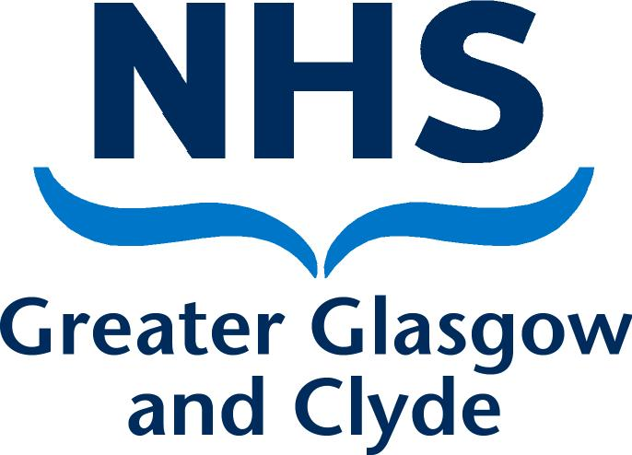

**PERSON SPECIFICATION FORM**

**Job Title: - Locum Consultant Obstetrician**

|  |  |  |
| --- | --- | --- |
| **Qualifications** | **Essential (√)** | **Desirable (√)** |
| GMC Registration and a Licence to Practise  Medically qualified with MRCOG or equivalent  Experience of O&G leading to CCT | √  √ |  |
| ATSM in obstetric speciality area or equivalent experience | √ |  |
| Proficiency in obstetric ultrasound to Level 3 | √ |  |

|  |  |  |
| --- | --- | --- |
| **Experience** | **Essential (√)** | **Desirable (√)** |
| Comprehensive general obstetrics and gynaecology leading to CST or equivalent. | √ |  |
| Gynaecology Ultrasound as independent practitioner |  | √ |
| Obstetric Ultrasound as independent practitioner | √ |  |
| Comprehensive experience of surgical management of gynaecological emergencies |  | √ |
| Experience of clinical practice in level 3 obstetric unit with annual birth rate >4000 births per year. | √ |  |
| Participation in advanced labour ward practice training courses e.g. SCOTTIE, ALSO, MOET or similar |  | √ |
| Higher qualification (MD or PhD) |  | √ |

|  |  |  |
| --- | --- | --- |
| **Behavioural Competencies** | **Essential (√)** | **Desirable (√)** |
| Ability to communicate with medical and nursing colleagues and other professionals within the Health Service | √ |  |
| Ability to work in multi-disciplinary team | √ |  |
| Flexible | √ |  |
| Excellent written and oral communication skills | √ |  |
| Ability to organise effectively | √ |  |
| Ability to effectively communicate with patients, relatives and staff | √ |  |
| Ability to sympathetically manage patients and relatives with malignancy | √ |  |
| Fully committed to patient safety and risk management culture | √ |  |

|  |  |  |
| --- | --- | --- |
| **Other** | **Essential (√)** | **Desirable (√)** |
| Experience in medical research and audit |  | √ |
| Experience in undergraduate and postgraduate medical education including PBL | √ |  |
| Experience in protocol and guideline development | √ |  |
| Fundamental IT skills: navigation of environment, word processing, managing emails, basic data management. | √ |  |

**10. DETAILS OF ARRANGEMENTS FOR APPLICANTS TO VISIT HOSPITAL**

Short-listed candidates are invited automatically by the Director of Human Resources to visit the hospitals concerned. If candidates on their own initiative have visited the hospital prior to short-listing, they will only be allowed expenses for that prior visit if they are subsequently short-listed. When it is thought that there will be difficulty in filling the post, the Director of Human Resources has the authority to approve a second visit.

**11. POSITION OF CONSULTANTS UNABLE FOR PERSONAL REASONS TO WORK FULL-TIME**

Any consultant who is unable for personal reasons to work full-time will be eligible to be considered for the post; if such a person is appointed, modification of the job content will be discussed on a personal basis in consultation with consultant colleagues.

### Details of Arrangements for Applicants to Visit the Hospitals

Dr Ros Jamieson

Clinical Director

Glasgow Royal Infirmary

Tel: 0141 211 5218 (Kathleen McGrath, PA)

# TERMS AND CONDITIONS OF SERVICE

The conditions of service are those laid down and amended from time to time by the Hospital and Medical & Dental Whitley Council.

|  |  |
| --- | --- |
| **TYPE OF CONTRACT** | Fixed Term |
| **GRADE AND SALARY** | Locum Consultant  £ 77,529 £ 104,525 per annum (pro rata)  New Entrants to the NHS will normally commence on the minimum point of the salary scale, (dependent on qualifications and experience). Salary is paid monthly by Bank Credit Transfer. |
| **HOURS OF DUTY** | Full Time 40.00 |
| **SUPERANNUATION** | New entrants to NHS Greater Glasgow and Clyde who are aged sixteen but under seventy five will be enrolled automatically into membership of the NHS Pension Scheme.  Should you choose to "opt out" arrangements can be made to do this via: [www.sppa.gov.uk](http://www.sppa.gov.uk) |
| **REMOVAL EXPENSES** | Assistance with removal and associated expenses may be given and would be discussed and agreed prior to appointment. |
| **EXPENSES OF CANDIDATES FOR APPOINTMENT** | Candidates who are requested to attend an interview will be given assistance with appropriate travelling expenses. Re-imbursement shall not normally be made to employees who withdraw their application or refuse an offer of appointment. |
| **TOBACCO POLICY** | NHS Greater Glasgow and Clyde operate a No Smoking Policy in all premises and grounds. |
| **DISCLOSURE SCOTLAND** | This post is considered to be in the category of “Regulated Work” and therefore requires a Disclosure Scotland Protection of Vulnerable Groups Scheme (PVG) Membership. |
| **CONFIRMATION OF ELIGIBILITY TO WORK IN THE UK** | NHS Greater Glasgow and Clyde (NHSGGC) has a legal obligation to  ensure that it’s employees, both EEA and non EEA nationals, are legally entitled to work in the United Kingdom. Before any person can commence employment within NHS GGC they will need to provide documentation to prove that they are eligible to work in the UK. Non EEA nationals will be required to show evidence that either Entry Clearance or Leave to Remain in the UK has been granted for the work which they are applying to do. Where an individual is subject to immigration control under no circumstances will they be allowed to commence until the right to work in the UK has been verified. ALL applicants regardless of nationality must complete and return the Confirmation of Eligibility to Work in the UK Statement with their completed application form. You will be required provide appropriate documentation prior to any appointment being made. |
| **REHABILITATION OF OFFENDERS ACT 1974** | The rehabilitation of Offenders act 1974 allows people who have been convicted of certain criminal offences to regard their convictions as “spent” after the lapse of a period of years. However, due to the nature of work for which you are applying this post is exempt from the provisions of Section 4 of the Rehabilitation of Offenders Act 1974 by virtue of the Rehabilitation of Offenders Act 1974 (Exceptions Orders 1975 and 1986). Therefore, applicants are required to disclose information about convictions which for other purposes are “spent” under the provision of the act in the event of employment, failure to disclose such convictions could result in dismissal or disciplinary action by NHS Greater Glasgow and Clyde. Any information given will be completely confidential. |
| **DISABLED APPLICANTS** | A disability or health problems does not preclude full consideration for the job and applications from people with disabilities are welcome. All information will be treated as confidential. NHS Greater Glasgow and Clyde guarantees to interview all applicants with disabilities who meet the minimum criteria for the post. You will note on our application form that we ask for relevant information with regard to your disability. This is simply to ensure that we can assist you, if you are called for interview, to have every opportunity to present your application in full. We may call you to discuss your needs in more detail if you are selected for interview. |
| **GENERAL** | NHS Greater Glasgow and Clyde operates flexible staffing arrangements whereby all appointments are to a grade within a department. The duties of an officer may be varied from an initial set of duties to any other set, which are commensurate with the grade of the officer. The enhanced experience resulting from this is considered to be in the best interest of both NHS Greater Glasgow and Clyde and the individual. |
| **EQUAL OPPORTUNITIES** | The postholder will undertake their duties in strict accordance with NHS Greater Glasgow and Clyde’s Equal Opportunities Policy. |
| **NOTICE** | The employment is subject to one months’ notice on either side, subject to appeal against dismissal. |
| **MEDICAL NEGLIGENCE** | In terms of NHS Circular 1989 (PCS) 32 dealing with Medical Negligence the Health Board does not require you to subscribe to a Medical Defence Organisation. Health Board indemnity will cover only Health Board responsibilities. It may, however, be in your interest to subscribe to a defence organisation in order to ensure you are covered for any work, which does not fall within the scope of the indemnity scheme. |

**FURTHER INFORMATION**

For further information on NHS Greater Glasgow and Clyde, please visit our website on [www.show.scot.nhs.uk](http://www.show.scot.nhs.uk)

**View all our vacancies** **at**: [www.nhsggc.org.uk/medicaljobs](http://www.nhsggc.org.uk/medicaljobs)

**Register for Job Alerts** **at**: [www.medicaljobs.scot.nhs.uk](http://www.medicaljobs.scot.nhs.uk)

**Applicants wishing further information about the post are invited to contact For an informal discussion please contact Dr Ros Jamieson, or Dr Catrina Bain Clinical Directors on 0141 211 5218**

**How to apply**

To apply for these posts please include your CV and names and addresses of 3 Referees, along with the following documents; (click on the hyperlinks to open)

[Medical and Dental Application and Equal Opportunities Monitoring Form](http://library.nhsggc.org.uk/mediaAssets/Recruitment/Medical%20Application%20form%20and%20Equal%20Opportunities%20Monitoring%20Form%20August%202012.doc)

[Declaration Form Regarding Fitness to Practice](http://www.nhsggc.org.uk/media/236816/fitness-to-practice-form.doc)

[Immigration Questionnaire](http://library.nhsggc.org.uk/mediaAssets/Recruitment/Immigration%20Form%20-%20Medical%20Staff%20Only.doc)

Alternatively please visit [www.nhsggc.org.uk/medicaljobs](http://www.nhsggc.org.uk/medicaljobs) and click on the “How to Apply” tab to access application for and CV submission information.

**Return of Applications**

Please return your application by email to [nhsggcrecruitment@nhs.net](mailto:nhsggcrecruitment@nhs.net) or to the recruitment address below;

Medical and Dental Recruitment Team

NHS Greater Glasgow and Clyde

Recruitment Services, 1st Floor

Modular Building, Gartnavel Royal Hospital

1055 Great Western Road

GLASGOW

G12 0XH

**CLOSING DATE**

The closing Date will be 22ND July 2016