GREATER GLASGOW AND CLYDE
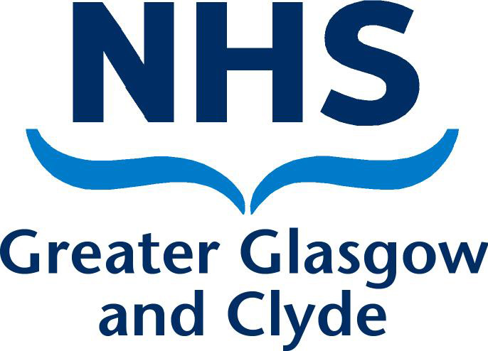

Clyde Biochemistry Department

MEMORANDUM

Royal Alexandra Hospital Vale of Leven Hospital Inverclyde Royal Hospital
Corsebar Road North Main Street Larkfield Road
PAISLEY ALEXANDRIA GREENOCK
PA2 9PN G83 0UA PA16 0XN

To: All Wards

From: Karen Brazier, Technical Service Manager

Date: 10/11/2020

Add on Tests – Hospital Users

To add a test request onto a previously taken sample please complete a paper request form. This should not be a Trakcare form. The request form should be sent to the laboratory clearly indicating that it is an add-on test. The request form is held as an audit trail of additional tests and the requester. Please do not send add on requests on scraps of paper.

The laboratory is unable to accept add on requests for unstable analytes. This applies in particular to bicarbonate. Samples are stored in the laboratory for about 4 days. Please see the laboratory handbook for further details.

Paper request forms can be ordered via PECOS, using the code G100456

All wards are advised to hold stock of paper copied in the event of unplanned IT downtime.

Karen Brazier
Technical Service Manager
Clyde Biochemistry.

